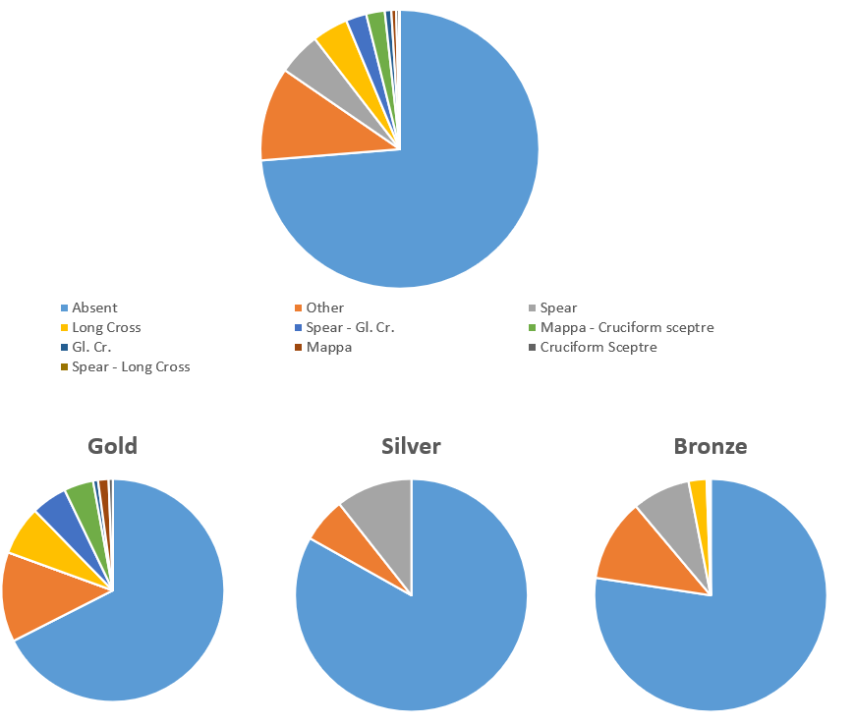
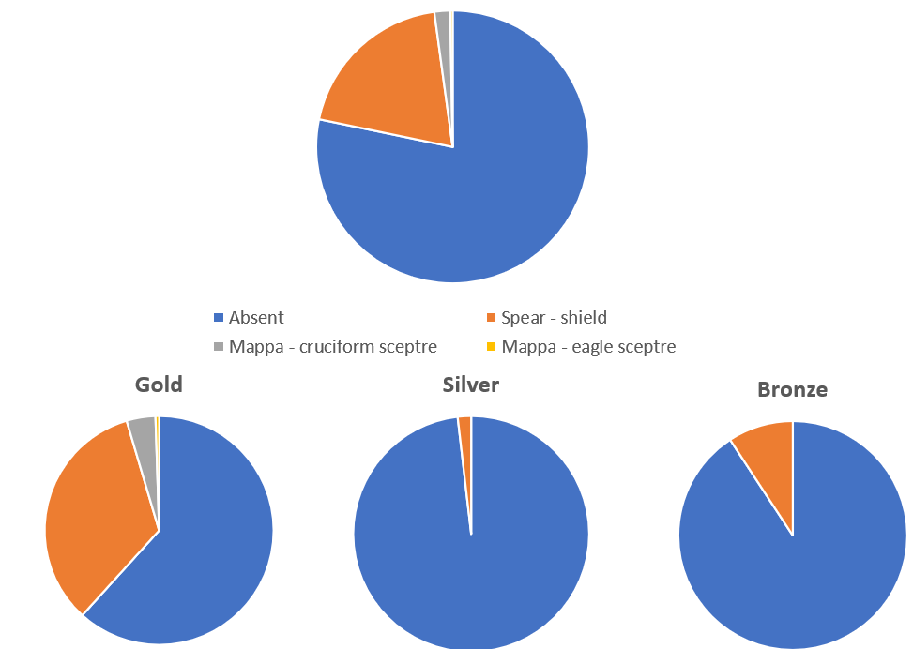
Figures
Figure 1 Distribution of attributes on the obverse Roman coins 379-491 overall and per metal class (RIC)

Figure 2 Distribution of attributes on the reverse of Roman coins (379-491) overall and per metal class (RIC)

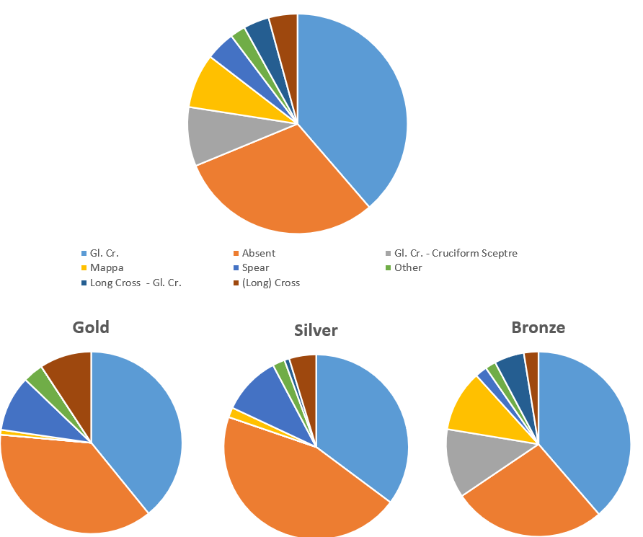

Figure 4 Appearance rates of headgear types on gold coins 379-491 (RIC)
Figure 3 Distribution of imperial attributes on the obverse of Byzantine coinage 491-711 overall and per metal class (DOC)

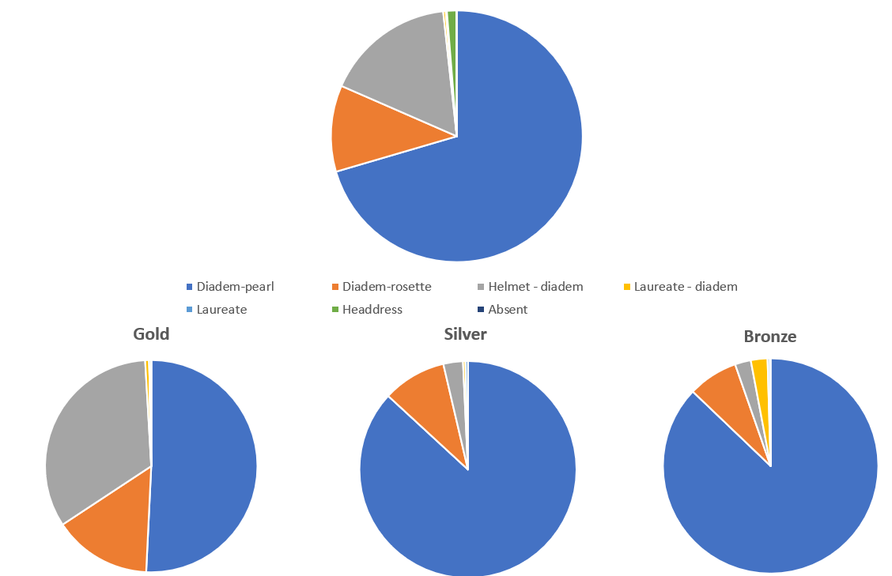
Figure 5 Distribution of headgear types on Roman coins 379-491 overall and per metal class (RIC)

Figure 6 Distribution of imperial attributes on Byzantine gold coins 491-711 (DOC)
Figure 8 Appearance rates of helmet/military types on Byzantine bronze coins (DOC)
Figure 7 Appearance rates of helmet / military types on Byzantine gold coins (DOC)

Figure 9 Distribution of attributes on the obverses of Byzantine bronze coins 491-711 (DOC)

Figure 10 Mappa types on gold coins per mint (379-491) (RIC)

