Images

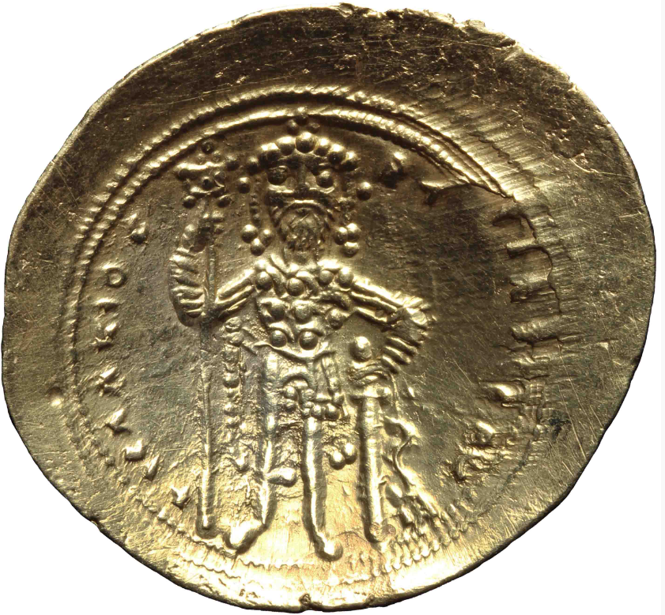
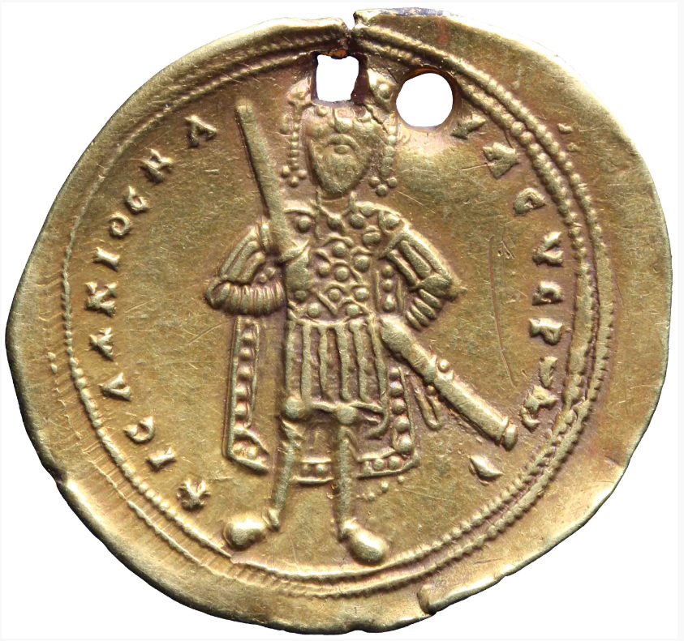
- Histamenon of Isaac I Komnenos (r. 1057-1059). Left: DOC 3.2 Isaac I - 1 (Sear 1844). Right: DOC 3.2 Isaac I – 2 (Sear 1843).

Source: (left) NNC, 1972-0503, https://nnc.dnb.nl/dnb-nnc-ontsluiting-frontend/#/collectie/object/1972-0503; (right) NNC, RO-13822, https://nnc.dnb.nl/dnb-nnc-ontsluiting-frontend/#/collectie/object/RO-13822;

2. Left: Solidus of Marcian (r. 450-457) - RIC X Marcian 523. Middle: Solidus of Justinian I (r. 527-565) – DOC 1 Justinian I – 1a. Right: Constantine IV (r. 668-685) – DOC 2.2 Constantine IV – 4 (Sear 1151).
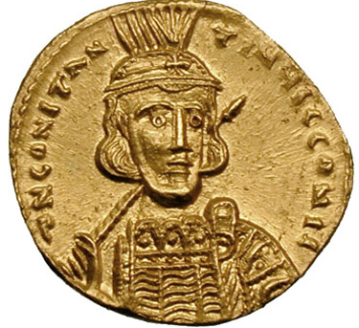
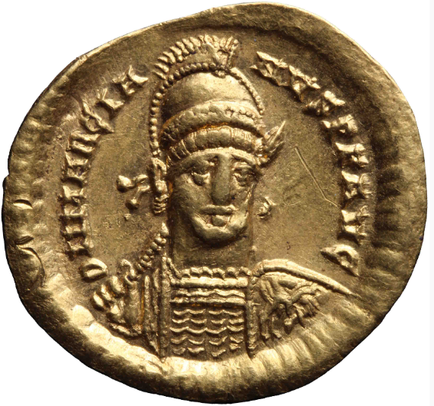
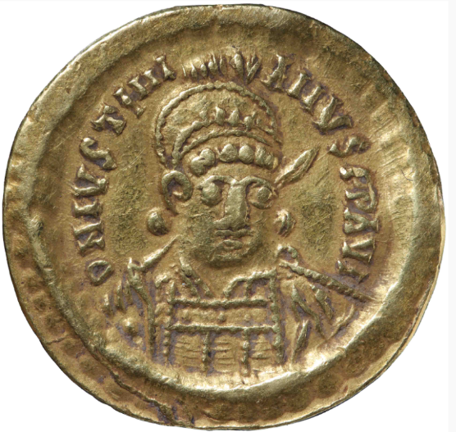

Sources: (left) NNC, RO-130013, https://nnc.dnb.nl/dnb-nnc-ontsluiting-frontend/#/collectie/object/RO-13013; (middle) NNC, RO-14046, https://nnc.dnb.nl/dnb-nnc-ontsluiting-frontend/#/collectie/object/RO-14046; (right) Wikimedia Commons, https://commons.wikimedia.org/wiki/File:Solidus-Constantine_IV-sb1151.jpg

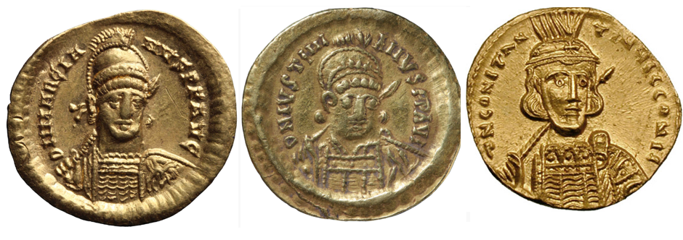
3. Folles of Constantine IV (r. 668-685). Left: DOC 2.2 Constantine IV – 28c. Right: DOC 2.2 Constantine IV – 25 (Sear 1170).
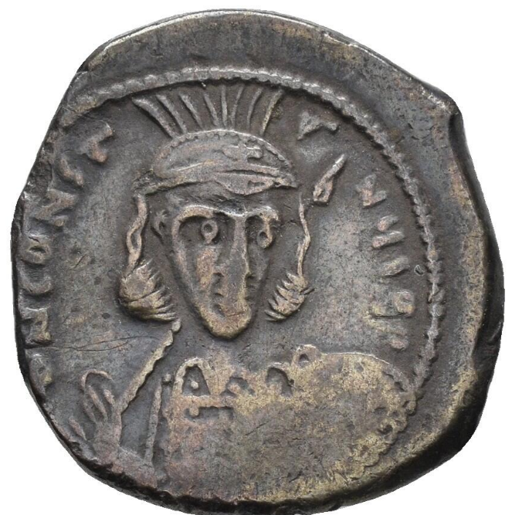
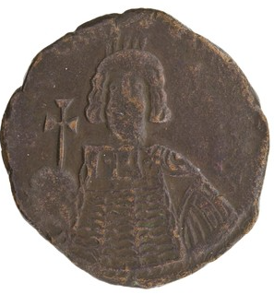

Sources: Left: ANS Byzantine 1944.100.16196, http://numismatics.org/collection/1944.100.16196?lang=nl. Right: Coin Archives, Auction 11 – Lot Number 288 – 25 March 2023.

4. Left: Solidus of Theodosius II (r. 402-450) – RIC X Theodosius II (East) 221. Middle: Follis of Tiberius II (r. 578-582) – DOC 1 Tiberius II - 11a. Right: Solidus of Maurice (r. 582-602)- DOC 1 Maurice – 2a.
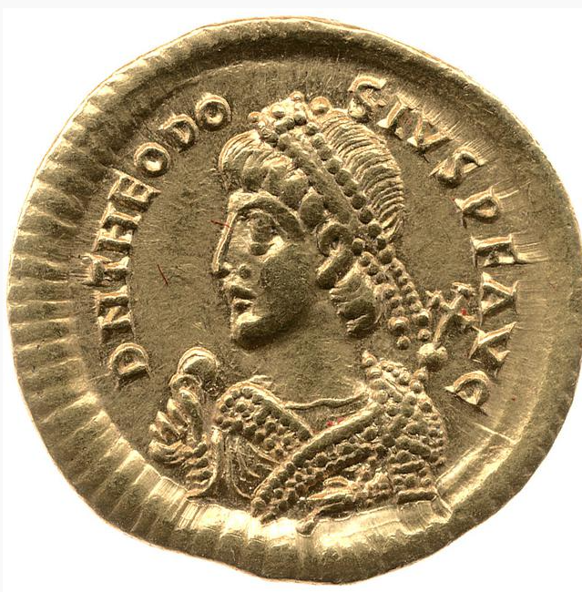
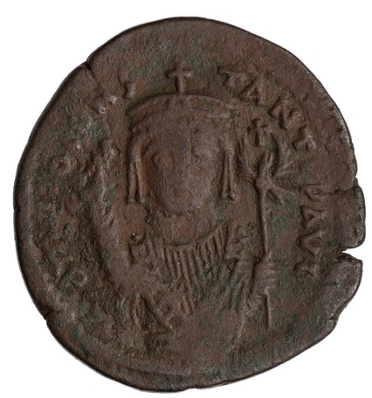
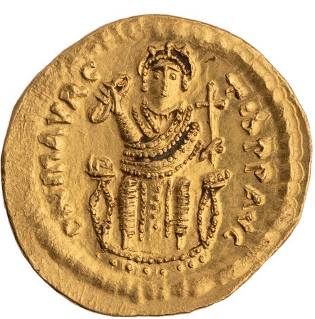

Sources: Left: British Museum, 1958,0702.1, https://www.britishmuseum.org/collection/object/C_1958-0702-1. Middle: ANS Byzantine 1971.289.2, http://numismatics.org/collection/1971.289.2?lang=nl; Right: ANS Byzantine, 1968.131.42, http://numismatics.org/collection/1968.131.42?lang=nl

5. Consular solidus of Heraclius and his father Heraclius the Elder – DOC 2.2 Interregnum – 10.
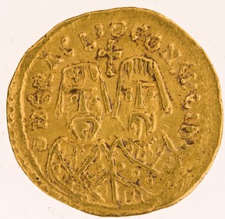

Source: ANS Byzantine 1944.100.13559, http://numismatics.org/collection/1944.100.13559?lang=nl

