CATALOGUE SUTOR - VICUS

NERO

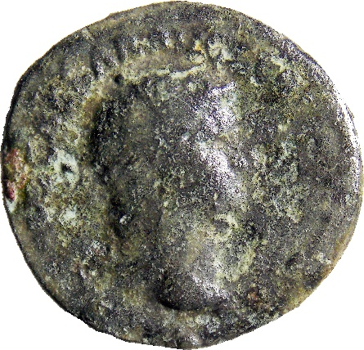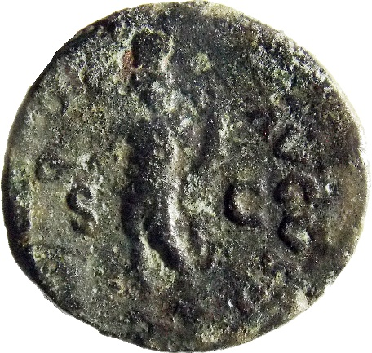
- Denomination: as
Metal: AE
Axis: 6; D: 23.4 x 22.3 mm; W: 4.22 g.
Mint: Rome
Dating: 62-68
Obv: [nero claud] CAESAR AV[g ger p m tr imp p p]
Head of Nero, radiate, right.
Rv: [geni]O – AVGVSTI; in field: S - C
Genius Populi Romani standing left, holding patera over flaming altar in right hand and cornucopiae in left.
Catalogue: RIC 215
Context: Sutor 2022, vicus; context 1188; area 2A, quadrant 4; inv.no. temp. SF 1039; 14.10.2022. Phase I.1

Flavian dynasty

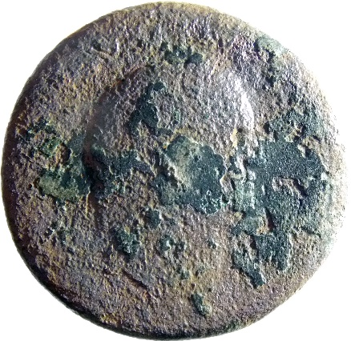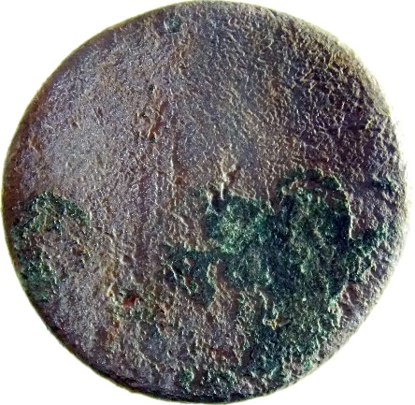
- Denomination: sestertius
Metal: AE
Axis: -; D: 32 mm; W: 19 g.
Mint: uncertain
Dating: 69-96
Obv: legend erased
Silhouette of a Flavian head, right.
Rv: legend erased
Silhouette standing.
Catalogue: -
Context: Sutor 2022, vicus; context 1188; quadrant 7; the room in the center of the quadrant, SW side; inv.no. temp. SF 1180; 24.10.2022. Phase II.1

Flavian dynasty

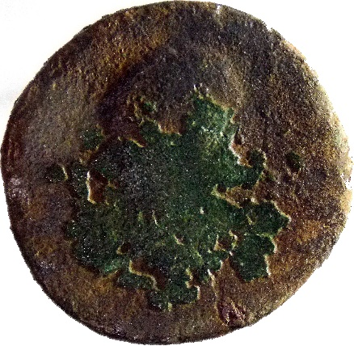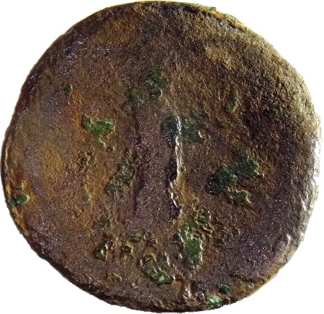
- Denomination: as
Metal: AE
Axis: 12; D: 25.7 mm; W: 7.62 g.
Mint: uncertain
Dating: 69-96
Obv: legend erased
Silhouette of a Flavian head, right.
Rv: legend erased
Silhouette standing.
Catalogue: -
Context: Sutor 2022, vicus; context 4392; area building no. 2; inv.no. temp. SF 1006; 10.10.2022. Phase II.1

DOMITIANUS

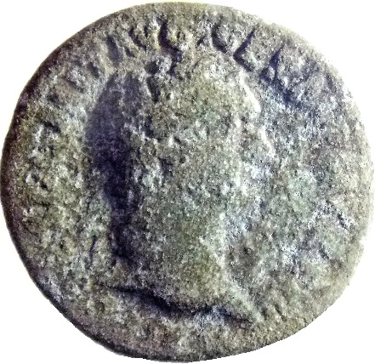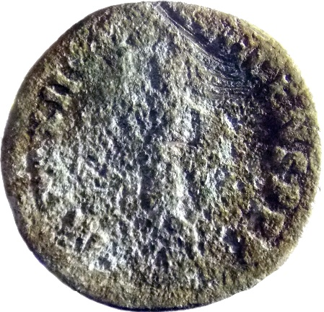
- Denomination: denarius - plated
Metal: AE
Axis: 6; D: 18.7 mm; W: 2.13 g.
Mint: uncertain
Dating: 95-96/post
Obv: IMP CAES DOMIT AVG GERM P M TR P XV
Head of Domitian, laureate, right.
Rv: IMP XXII C[os xvii c]ENS P P P
Minerva standing left, holding spear.
Catalogue: cf. RIC II.1 790
Context: Sutor 2022, vicus; area 2A, quadrant 7; room 4; on the wall, western side; inv.no. temp. SF 1287; 31.10.2022. Phase II.1

TRAIANUS

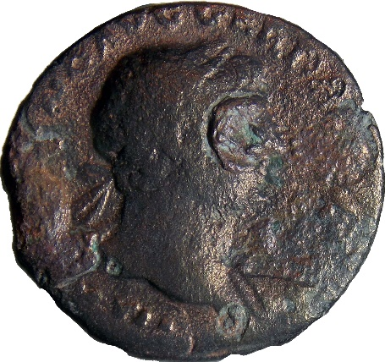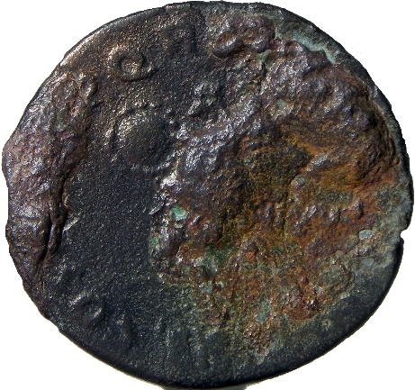
- Denomination: denarius - plated
Metal: AE
Axis: 6; D: 17.7 mm; W: 2.24 g.
Mint: uncertain
Dating: 107-108/post
Obv: IMP [trai]ANO AVG GER D[ac p m tr p]
Bust of Trajan, laureate, draped, right.
Rv: COS [v p p s p] Q [r optimo princ]
Trophy. Only the round shield is visible.
Catalogue: cf. RIC 147B; MIR 268
Context: Sutor 2022, vicus; context 1188; area 2A, quadrant C9; inv.no. temp. SF 1144; 21.10.2022. Phase I.2

TRAIANUS

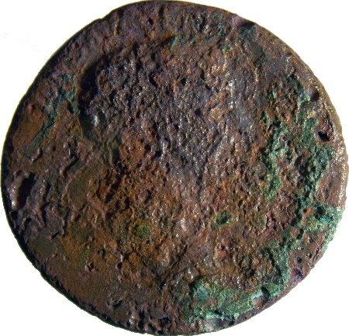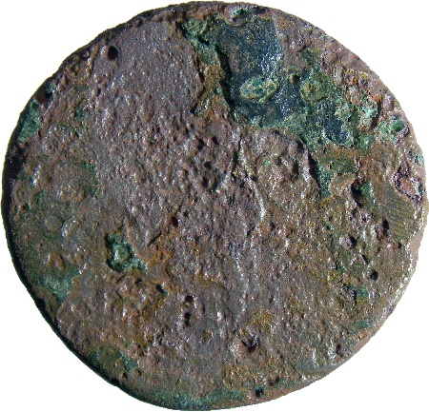
- Denomination: sestertius
Metal: AE
Axis: 6; D: 32.1 mm; W: 18.94 g.
Mint: Rome
Dating: 103-117
Obv: legend erased
Silhouette of Trajan’a head, laureate, right.
Rv: legend erased
Silhouette of a female person standing left.
Catalogue: -
Context: Sutor 2022, vicus; area 2A, quadrant 7; room 3; the testing quadrant, NE corner; adobe layer; inv.no. temp. SF 1288; 31.10.2022. Phase I.2

TRAIANUS

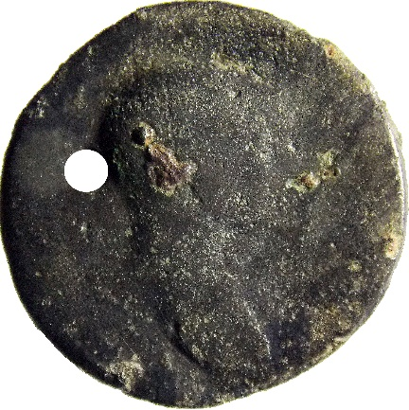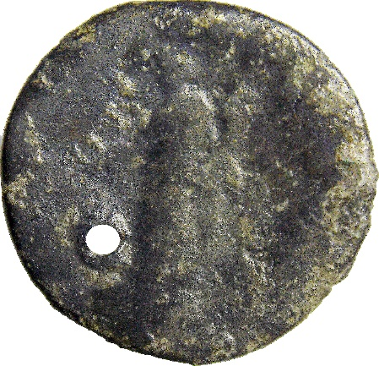
- Denomination: as
Metal: AE
Axis: 6; D: 27.4 x 26.2 mm; W: 8.33 g.
Mint: Rome
Dating: 103-117
Obv: legend erased
Silhouette of Trajan’a head, laureate, right.
Rv: legend erased
Silhouette of a female person standing left, holding cornucopiae in left hand.
Catalogue: -
Remark: coin was pierced.
Context: Sutor 2022, vicus; context 2302; area 2B; inv.no. temp. SF 310; 15.07.2022. Phase I.2

HADRIANUS

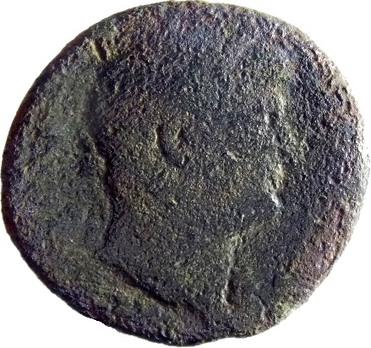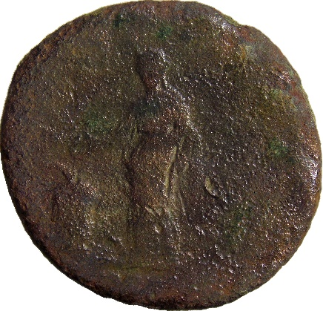
- Denomination: as
Metal: AE
Axis: 5; D: 28 x 26 mm; W: 11.09 g.
Mint: Rome
Dating: 125-127
Obv: legend erased
Head of Hadrian, laureate, right.
Rv: legend erased
Salus standing left, holding patera and sceptre; to left, snake coiled around altar.
Catalogue: cf. RIC II.3, 828
Context: Sutor 2022, vicus; area 2, walking level of the road; inv.no. temp. SF 573; 03.08.2022. Phase I.2

HADRIANUS

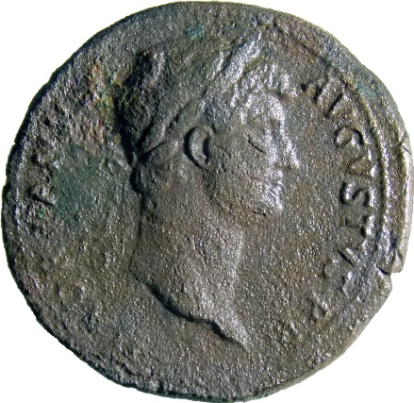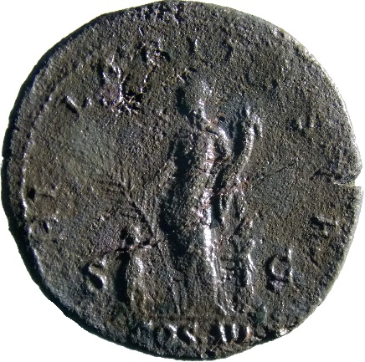
- Denomination: sestertius
Metal: AE
Axis: 5; D: 34.2 mm; W: 24.98 g.
Mint: Rome
Dating: 128-129
Obv: HADRIANVS – AUGUSTVS P P
Head of Hadrian, laureate, right.
Rv: HI-LARITAS; in field: S – C
Exergue: COIS III
Hilaritas, rarely naked to waist, standing left, holding palm and cornucopia; flanking her, male and female children grasping her palm and dress respectively.
Catalogue: RIC II.3, 988
Context: Sutor 2022, vicus; context 1188; area 2B, quadrant E5; topo no. 354; inv.no. temp. SF 104; 05.07.2022. Phase II.1

HADRIANUS

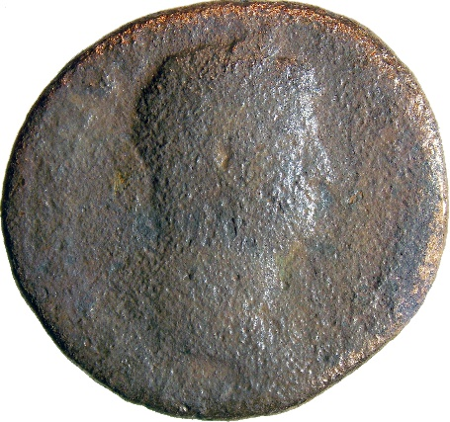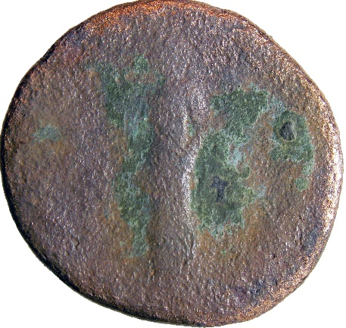
- Denomination: as
Metal: AE
Axis: 6; D: 26 x 24.3 mm; W: 7.86 g.
Mint: Rome
Dating: 129-130
Obv: HADRIANVS – [august]VS
Head of Hadrian, laureate, right.
Rv: legend erased; in field: S - C
Silhouette of Tranquillitas standing left.
Catalogue: RIC II.3, 1254
Context: Sutor 2022, vicus; context 1188; area 2A, the bystander 11-12; inv.no. temp. SF 1100; 19.10.2022. Phase II.1

HADRIANUS

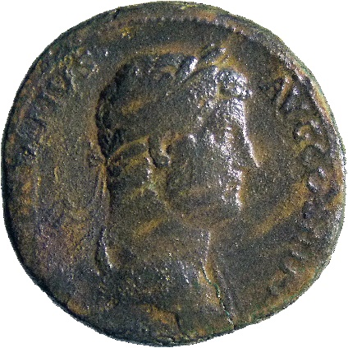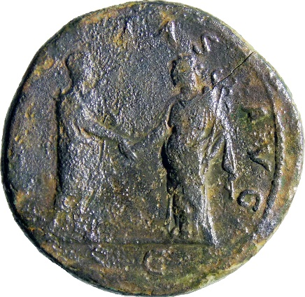
- Denomination: sestertius
Metal: AE
Axis: 6; D: 31.8 mm; W: 25.34 g.
Mint: Rome
Dating: 133-135
Obv: HADRIANVS – AVG COS III P P
Bust of Hadrian, laureate, draped, right, viewed from side.
Rv: [felici]TAS - AVG; exergue: S - C
Hadrian standing right, holding scroll and clasping hands with Felicitas, standing left, holding caduceus.
Catalogue: RIC II.3, 2082
Context: Sutor 2022, vicus; context 1188; area 2B, quadrant A5; inv.no. temp. SF 330; 18.07.2022. Phase I.2

HADRIANUS

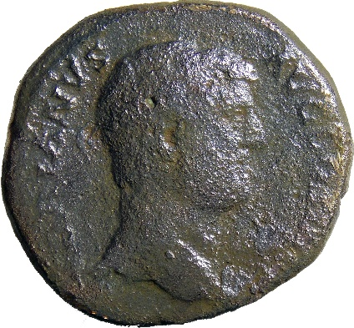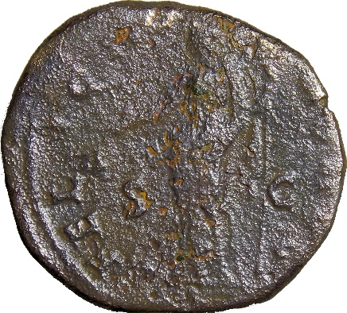
- Denomination: as
Metal: AE
Axis: 5; D: 29.5 mm; W: 20.17 g.
Mint: Rome
Dating: 136
Obv: HADRIANVS – AVG COS III [p p]
Head of Hadrian, bare, right.
Rv: FELICI[tas a]VG; in field: S - C
Felicitas standing left, holding branch and long caduceus.
Catalogue: RIC II.3, 2256
Context: Sutor 2022, vicus; context 1188; area 2B, excavated ground; inv.no. temp. SF 956; 24.09.2022. Phase I.2

HADRIANUS

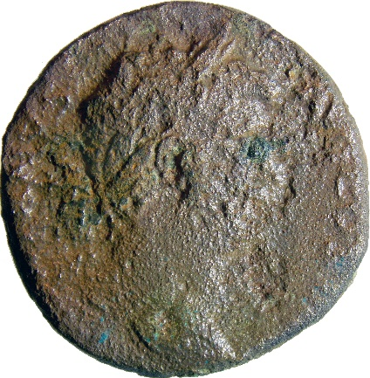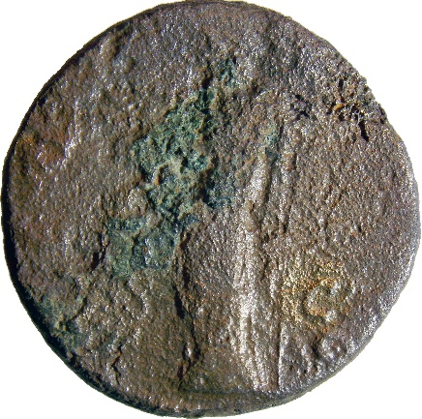
- Denomination: sestertius
Metal: AE
Axis: 5; D: 29.5 mm; W: 20.17 g.
Mint: Rome
Dating: 137-138
Obv: [hadrian]VS – [aug] COS III [p p]
Head of Hadrian, laureate, right.
Rv: AEQ[vitas aug]; in field: [s] - C
Aequitas standing left, holding scales and sceptre.
Catalogue: RIC II.3, 2371
Context: Sutor 2022, vicus; context 1188; area 2A, quadrant 7; room 1; inv.no. temp. SF 1248; 27.10.2022. Phase II.1

HADRIANUS

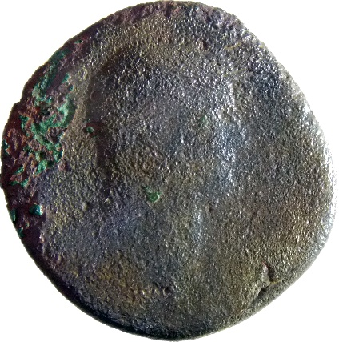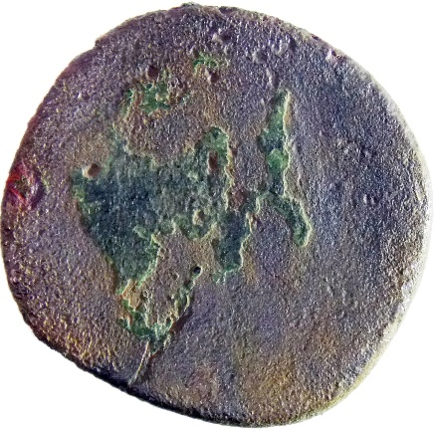
- Denomination: as
Metal: AE
Axis: -; D: 25.6 x 23.9 mm; W: 9.06 g.
Mint: Rome
Dating: 117-138
Obv: legend erased
Head of Hadrian, right.
Rv: erased
Catalogue: -
Context: Sutor 2022, vicus; context 1188; area 2A, quadrant 8; outside big room, near the southern wall; inv.no. temp. SF 1147; 21.10.2022. Phase II.1

HADRIANUS

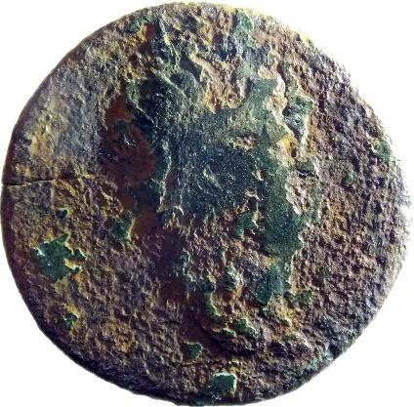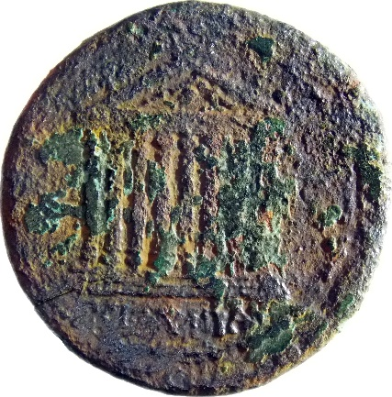
- Denomination: provincial coin
Metal: AE
Axis: 6; D: 28.5 mm; W: 11.44 g.
Mint: Koinon of Bithynia
Dating: 117-138
Obv: legend erased
Head of Hadrian, radiate, right.
Rv: [κοι-νον] ΒΕΙΘΥΝΙΑϹ
Temple with eight columns on podium of two steps.
Catalogue: RPC III, 1016
Context: Sutor 2022, vicus; context 1188; area 2B, bystander A1’-A’1’; inv.no. temp. SF 518; 28.07.2022. Phase II.1

ANTONINUS PIUS

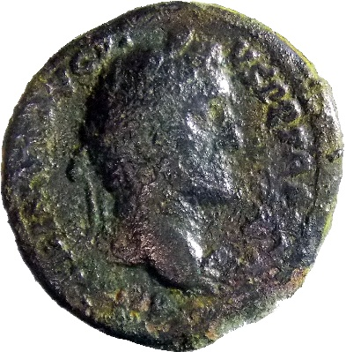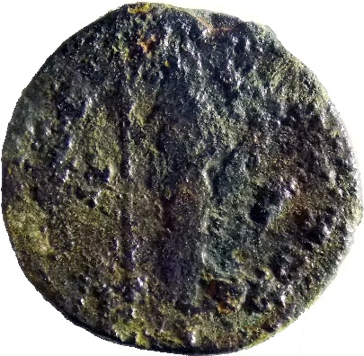
- Denomination: denarius - plated
Metal: AR+AE
Axis: 7; D: 17.6 mm; W: 1.78 g.
Mint: uncertain
Dating: 140-143/post
Obv: [antoninus a]VG PI-VS P P TR P [cos iii]
Head of Antoninus Pius, laureate, right.
Rv: [conco]RD [ia a]VG
Concordia, standing right, holding sceptre in right hand and corucopiae in left.
Catalogue: cf. RIC 65c
Context: Sutor 2022, vicus; context 1188; area 2B; from the bystander C5-D5; inv.no. temp. SF 570; 03.08.2022. Phase I.2

ANTONINUS PIUS

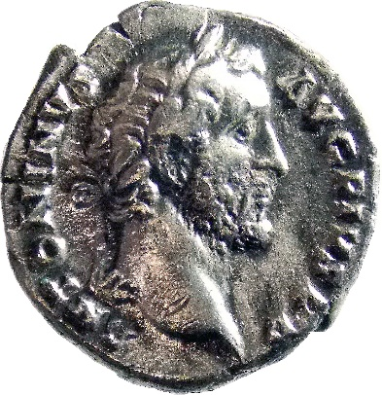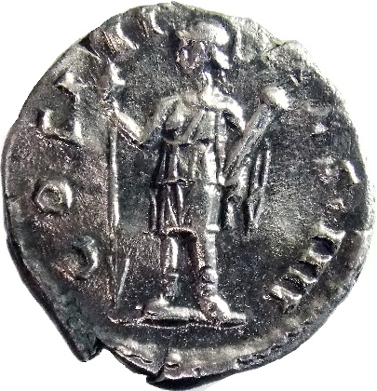
- Denomination: denarius
Metal: AR
Axis: 6; D: 18.2 mm; W: 2.90 g.
Mint: Rome
Dating: 143-144
Obv: ANTONINVS - AVG PIVS P P
Head of Antoninus Pius, laureate, right.
Rv: COS III – [d]ES IIII
Virtus, helmeted, in military dress, standing front, head left, holding vertical spear reversed in right hand and parazonium upwards in left.
Catalogue: RIC 118
Context: Sutor 2022, vicus; area 2B, top soil on the road, second stone level; inv.no. temp. SF 564; 03.09.2022. Phase II.1

ANTONINUS PIUS

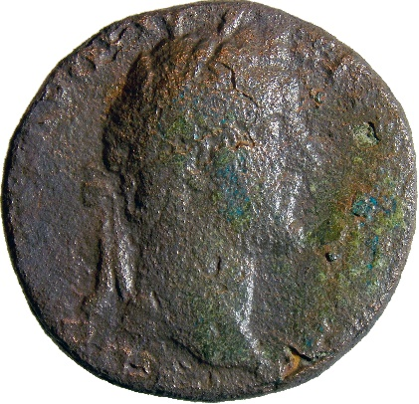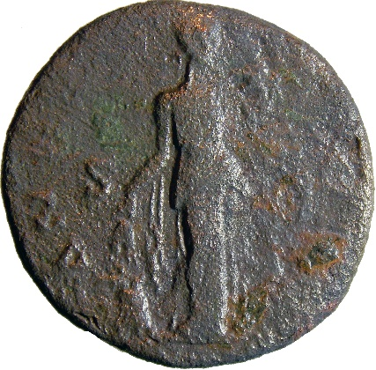
- Denomination: As
Metal: AE
Axis: 5; D: 24.5 x 23.7 mm; W: 9.05 g.
Mint: Rome
Dating: 140-144
Obv: [Antoninus] AVG PI-VS P [p tr p cos iii)
Head of Antoninus Pius, laureate, right.
Rv: ANN[ona aug]; in field: S – [c]
Annona, draped, standing right, holding two corn-ears in right hand over modius and corn-ears and cornucopiae in left; at feet right, prow right.
Catalogue: RIC 675
Context: Sutor 2022, vicus; quadrant 7; room 3; walking level with fired traces; near the room’s western wall; inv.no. temp. SF 1259; 27.10.2022. Phase I.2

ANTONINUS PIUS

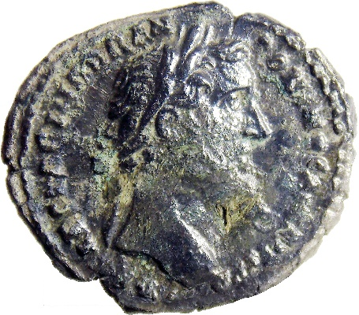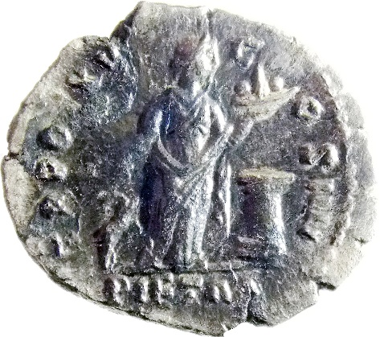
- Denomination: denarius
Metal: AR
Axis: 6; D: 19.7 x 16.6 mm; W: 2.82 g.
Mint: Rome
Dating: 151-152
Obv: IMP CAES T AEL HADR ANTONINVS AVG PIVS P P
Head of Antoninus Pius, laureate, right.
Rv: TR POT XV – C-OS IIII
Exergue: PIETAS
Pietas, draped, standing right, in front of altar, holding with right hand fore-legs of hind and holding dish of fruit on left hand.
Catalogue: RIC 217
Context: Sutor 2022, vicus; context 1188; area 2A, quadrant 8; room 6; walking level consisting of burning bits and adobe; inv.no. temp. SF 1263; 28.10.2022. Phase I.2

ANTONINUS PIUS

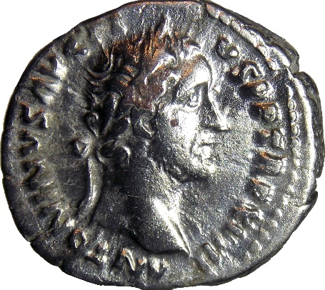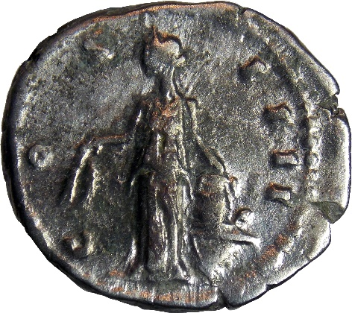
- Denomination: denarius
Metal: AR
Axis: 6; D: 18.9 x 17.1 mm; W: 3.20 g.
Mint: Rome
Dating: 153-154
Obv: ANTONINVS AVG PI-VS P P TR P XVII
Head of Antoninus Pius, laureate, right.
Rv: COS IIII
Annona, draped, standing left, holding two corn-ears downwards in right hand and setting left on modius set on prow, right.
Catalogue: RIC 231
Context: Sutor 2022, vicus; context 1188; area 2A, quadrant 7; room 8; opus signinum floor; between the wall and the quadrant SE bystander, in front of the gravel floor; inv.no. temp. SF 1220; 25.10.2022. Phase II.1

ANTONINUS PIUS

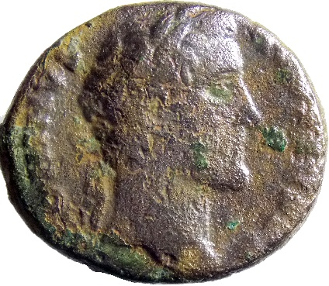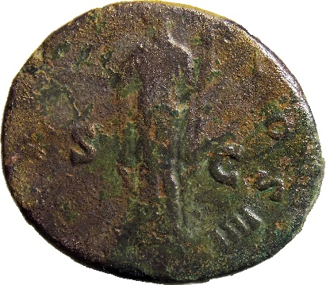
- Denomination: as
Metal: AE
Axis: 12; D: 26 x 22.4 mm; W: 9.67 g.
Mint: Rome
Dating: 138-161
Obv: ANTONINVS – [pius] AVG P P
Head of Antoninus Pius, laureate, right.
Rv: TR [pot c]OS IIII; in field: S - C
S Ceres, standing left, extending right hand and holding torch.
Catalogue: RIC 830
Context: Sutor 2022, vicus; area 2A, quadrant 4; inv.no. temp. SF 1038; 14.10.2022. Phase II.1

ANTONINUS PIUS

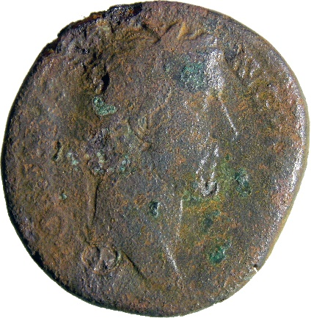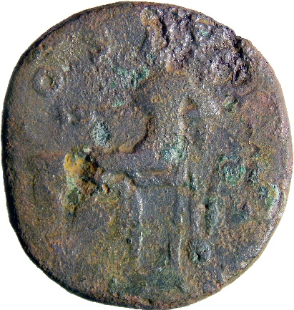
- Denomination: dupondius
Metal: AE
Axis: 12; D: 25.3 x 23.9 mm; W: 14.37 g.
Mint: Rome
Dating: 138-161
Obv: [anto]NINVS – PIVS AVG P P
Head of Antoninus Pius, laureate, right.
Rv: [c]OS IIII
Salus, seated left, feeding snake coiled round altar and resting left elbow on rudder.
Catalogue: RIC 799
Context: Sutor 2022, vicus; context 1188; area 2A, quadrant 12; inv.no. temp. SF 1284; 29.10.2022. Phase II.1

ANTONINUS PIUS

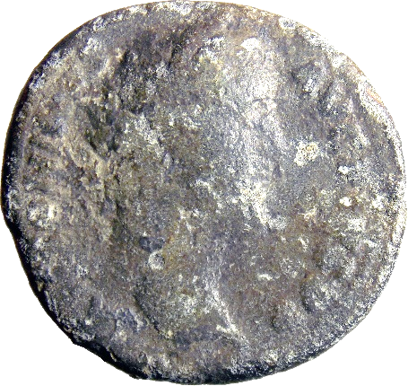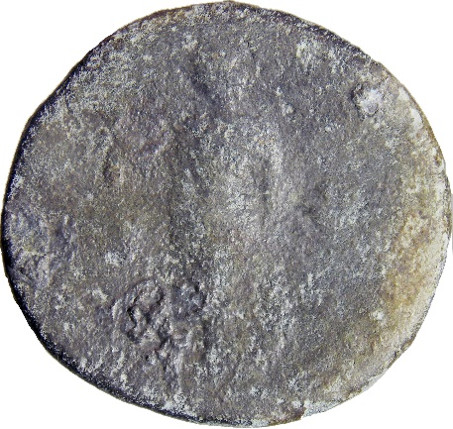
- Denomination: as
Metal: AE
Axis: 6; D: 26.9 x 25.4 mm; W: 8.07 g.
Mint: Rome
Dating: 138-161
Obv: ANTONINVS AVG PIVS P P
Head of Antoninus Pius, laureate, right.
Rv: legend erased
Female silhouette standing.
Catalogue: -
Context: Sutor 2022, vicus; context 1188; area 2A, quadrant 9; metal detecting within the building; inv.no. temp. SF 1101; 19.10.2022. Phase II.2

ANTONINUS PIUS

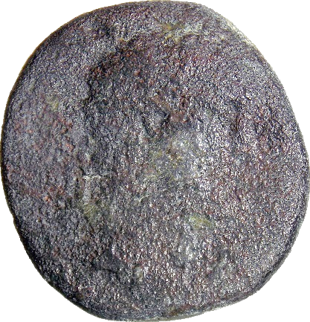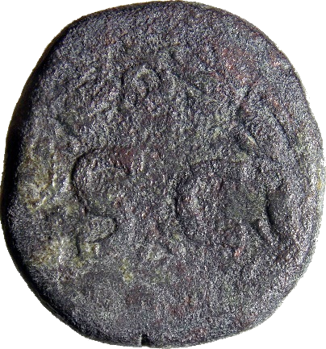
- Denomination: provincial coin
Metal: AE
Axis: 12; D: 24.5 x 22.8 mm; W: 12.30 g.
Mint: Antioch (Syria)
Dating: 138-161
Obv: legend erased
Radiate head of Antoninus Pius, right.
Rv: S C and below, letter Δ, in laurel wreath.
Catalogue: RPC IV.3, 7002
Context: Sutor 2022, vicus; context 1188; area 2A, quadrant 7; room 3; inv.no. temp. SF 1281; 29.10.2022. Phase I.2

ANTONINUS PIUS: Faustina I (Diva)

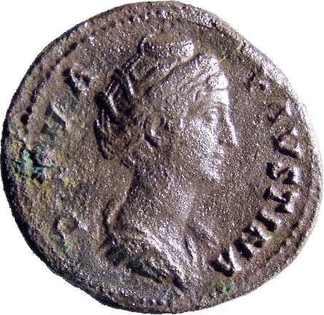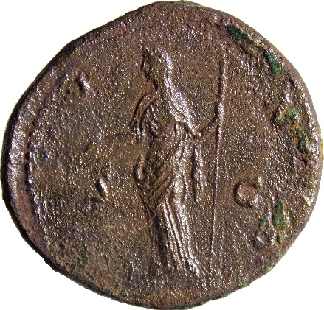
- Denomination: sestertius
Metal: AE
Axis: 11; D: 33.9 x 31.4 mm; W: 24.715 g.
Mint: Rome
Dating: 141
Obv: DIVA FAVSTINA
Bust of Faustina I, draped, right, hair elaborately waved and coiled in bands across head and drawn up at back and piled in a round coil on top.
Rv: [i]V-N[o]; in field: S – C
Juno, diademed, veiled, standing left, holding patera and sceptre.
Catalogue: RIC 1143
Context: Sutor 2022, vicus; context 1188; area 2B; bystander B3-C3, near the wall corner on the outer side; inv.no. temp. SF 552; 30.07.2022. Phase I.2

ANTONINUS PIUS: Faustina I (Diva)

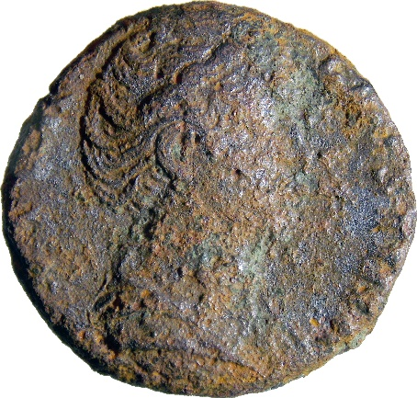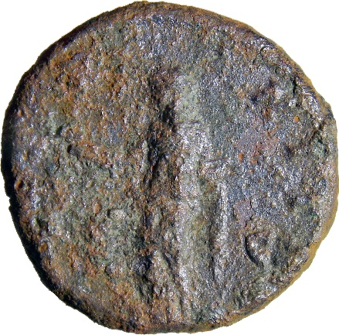
- Denomination: as
Metal: AE
Axis: 5; D: 24.5 x 23.4 mm; W: 9.59 g.
Mint: Rome
Dating: 141
Obv: DIVA FAVSTINA
Bust of Faustina I, draped, right, hair elaborately waved and coiled in bands across head and drawn up at back and piled in a round coil on top.
Rv: [aeter]NIT[as]; in field: S – C
Pietas, standing left, raising right hand and holding box of incense.
Catalogue: RIC 1161
Context: Sutor 2022, vicus; area 2B; Roman road level; inv.no. temp. SF 593; 04.08.2022. Phase I.2

ANTONINUS PIUS: Faustina I (Diva)

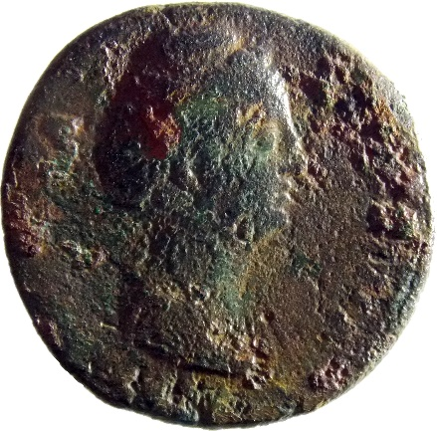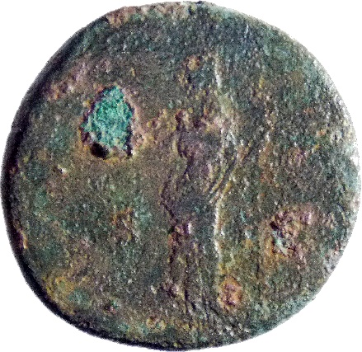
- Denomination: dupondius
Metal: AE
Axis: 6; D: 26.5 x 25.5 mm; W: 12.20 g.
Mint: Rome
Dating: 141
Obv: [div]A FAVSTINA
Bust of Faustina I, draped, right, hair elaborately waved and coiled in bands across head and drawn up at back and piled in a round coil on top.
Rv: [augusta]; in field: S – C
Vesta, veiled, draped, standing left, holding palladium on extended right hand and long sceptre, sloping slightly to left, in left hand.
Catalogue: RIC 1179
Context: Sutor 2022, vicus; area 2A; quadrant 12; while cleaning the E-W wall; inv.no. temp. SF 1186; 24.10.2022. Phase II.1

MARCUS AURELIUS

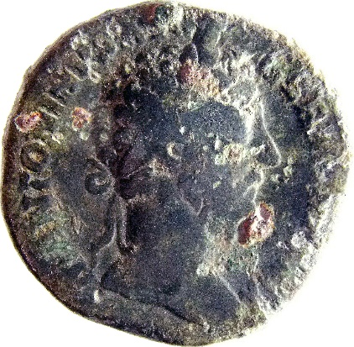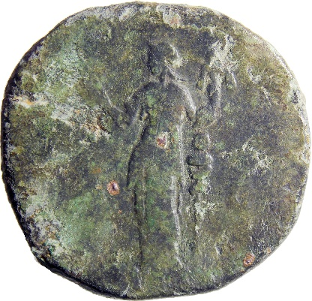
- Denomination: sestertius
Metal: AE
Axis: 12; D: 30.4 x 28.6 mm; W: 24.45 g.
Mint: Rome
Dating: 174-175
Obv: M ANTONINVS AVG - GERM [tr p x]IX
Head of Marcus Aurelius, laureate, right.
Rv: legend erased; in field: S - C
Fides, draped, standing left, holding caduceus in right hand and standard.
Catalogue: RIC 1138
Context: Sutor 2022, vicus; context 1188; area 2A; quadrant 7; in the second room from west, near the wall; inv.no. temp. SF 1189; 24.10.2022. Phase II.1

MARCUS AURELIUS: Lucius Verus (Augustus)

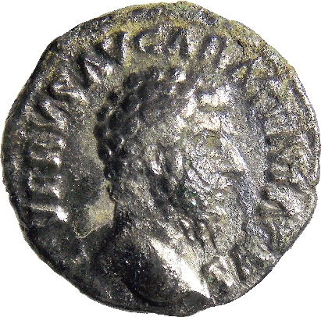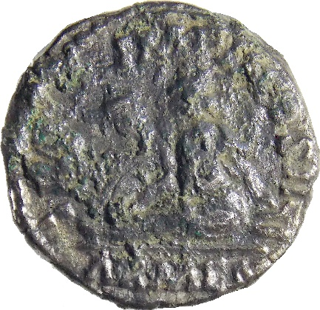
- Denomination: denarius
Metal: AR
Axis: 6; D: 16.8 mm; W: 2.82 g.
Mint: Rome
Dating: 163
Obv: L VERVS AVG ARMENIACVS
Head of Lucius Verus, bare, right.
Rv: [tr p iii] IMP [ii] COS II
Exergue: ARMEN
Armenia seated left on ground, surrounded by arms, resting left hand on bow and quiver; before her, standard.
Catalogue: RIC 501
Context: Sutor 2022, vicus; context 4584; inv.no. temp. SF 960; 29.09.2022. Phase I.2

MARCUS AURELIUS: Antoninus Pius (Divus)

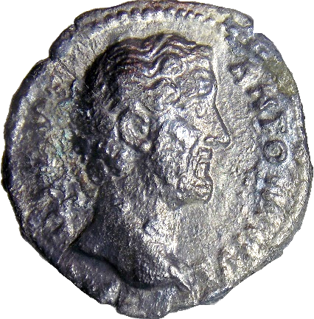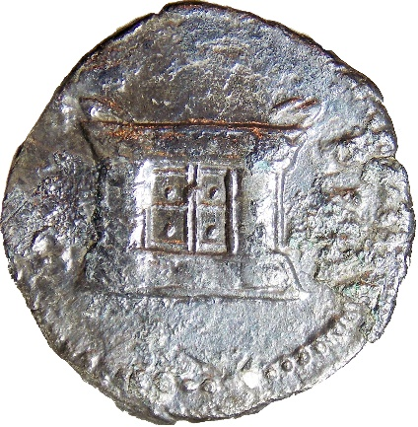
- Denomination: denarius
Metal: AR
Axis: 12; D: 18.1 mm; W: 2.47 g.
Mint: Rome
Dating: 161
Obv: D[ivus] - ANTONINVS
Head of Antoninus Pius, bare, right.
Rv: DIVO – PI[o]
Square altar.
Catalogue: RIC 441
Context: Sutor 2022, vicus; context 1188; area 2A; quadrant C8; room 6; inv.no. temp. SF 1242; 26.10.2022. Phase I.2

MARCUS AURELIUS: Faustina II (Augusta)

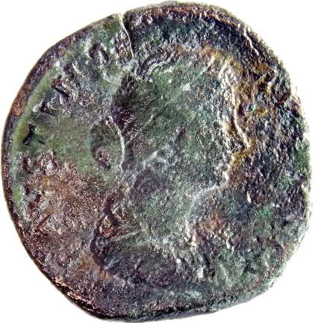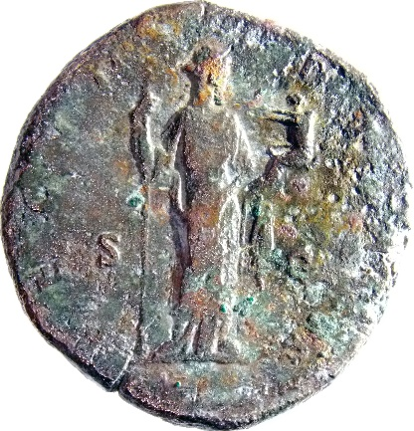
- Denomination: sestertius
Metal: AE
Axis: 6; D: 32.4 x 30.4 mm; W: 27.35 g.
Mint: Rome
Dating: 161-175
Obv: FAVSTINA [augus]TA
Bust of Faustina II, draped, hair elaborately waved in nearly vertical lines and fastened in a low chignon at back of head, down cheek, curls, right.
Rv: FECVN-DITAS; in field: S – C
Fecunditas, draped, standing right, holding sceptre in right hand and infant in left arm.
Catalogue: RIC 1638
Context: Sutor 2022, vicus; context 1188; area 2A; excavated ground; inv.no. temp. SF 1065; 18.10.2022. Phase I.2

MARCUS AURELIUS: Faustina II (Augusta)

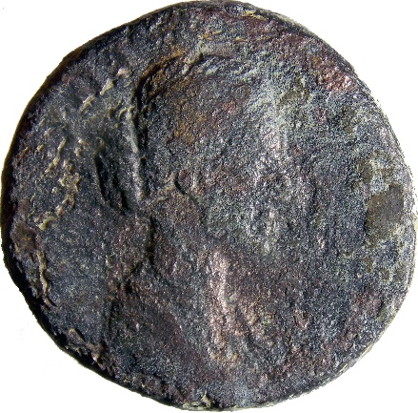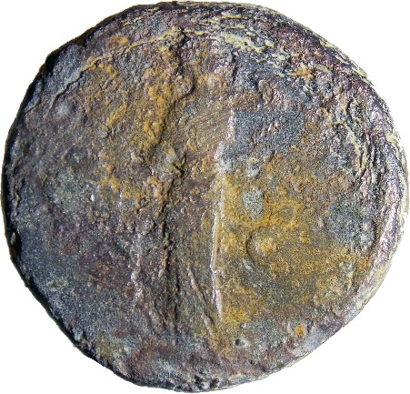
- Denomination: as
Metal: AE
Axis: 5; D: 24.5 x 23.3 mm; W: 11.17 g.
Mint: Rome
Dating: 161-175
Obv: [faust]INA AVGV[sta]
Bust of Faustina II, draped, hair elaborately waved in nearly vertical lines and fastened in a low chignon at back of head, down cheek, curls, right.
Rv: [ven]V[s]; in field: S – C
Venus, draped, standing left, holding apple in right hand and adjusting hair with left hand.
Catalogue: RIC 1684
Context: Sutor 2022, vicus; inv.no. temp. SF 588; 04.08.2022. Phase I.2

MARCUS AURELIUS: Lucilla (Augusta)

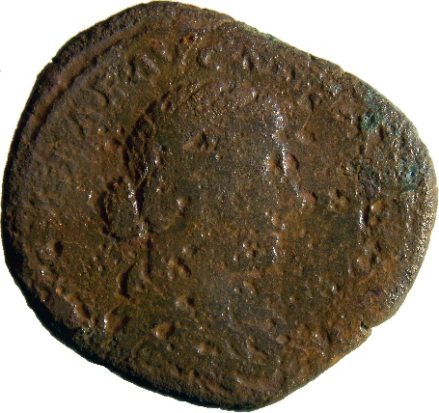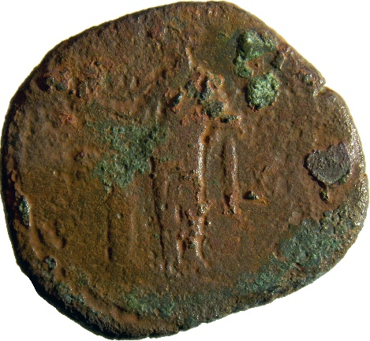
- Denomination: as
Metal: AE
Axis: 6; D: 26.2 x 22.9 mm; W: 10.36 g.
Mint: Rome
Dating: 164-169
Obv: [lucil]LAE AVG AN[tonini aug f]
Bust of Lucilla, hair waved and fastened in a low chignon at back of head, draped, right.
Rv: V-E[sta]; in field: S – C
Vesta, veiled, draped, standing left by altar, holding simpulum in right hand and palladium in left hand.
Catalogue: RIC 1780
Context: Sutor 2022, vicus; context 1188; area 2A; quadrant C7; second room from west; inv.no. temp. SF 1199; 24.10.2022. Phase II.1

COMMODUS

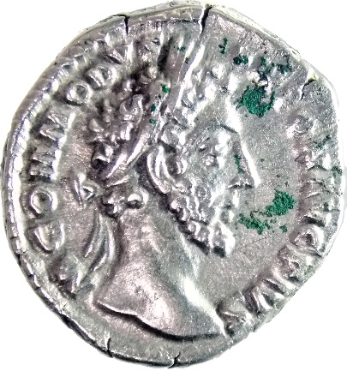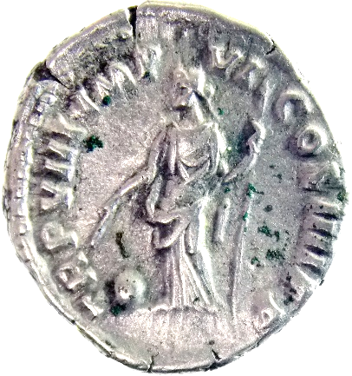
- Denomination: denarius
Metal: AR
Axis: 12; D: 17.6 mm; W: 3.33 g.
Mint: Rome
Dating: 183
Obv: M COMMODVS - ANTON AVG PIVS
Head of Commodus, laureate, right.
Rv: TR P VIII IMP VI COS IIII P P
Providentia, draped, standing left, holding wand in right hand over globe on ground left and vertical sceptre in left hand.
Catalogue: RIC 65
Context: Sutor 2022, vicus, context 1188; Area 2A; quadrant 8; room 5, floor; the mortar with pebble stones; inv.no. temp. SF 1229; 26.10.2022. Phase II.2

COMMODUS

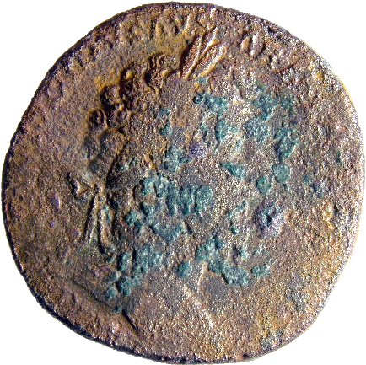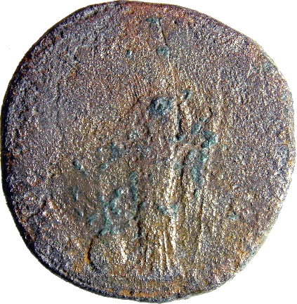
- Denomination: sestertius
Metal: AE
Axis: 5; D: 30.6 mm; W: 25.58 g.
Mint: Rome
Dating: 183
Obv: [m co]MMODVS ANT[oninus aug pius]
Head of Commodus, laureate, right.
Rv: PRO[v aug p m tr p viii imp vi cos iiii p p]; in field: S – C
Providentia, draped, standing left, holding wand in right hand over globe on ground left and vertical sceptre in left hand.
Catalogue: RIC 379a
Context: Sutor 2022, vicus, context 2004; Area 2B; inv.no. temp. SF 521; 28.07.2022. Phase I.2

SEPTIMIUS SEVERUS

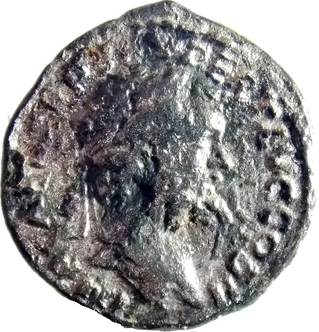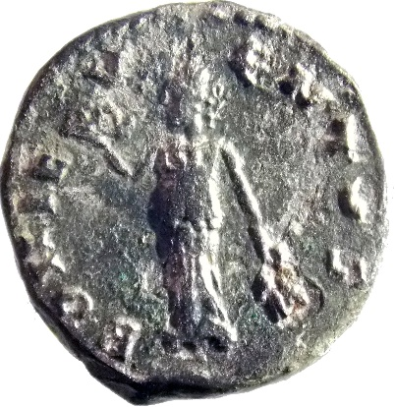
- Denomination: denarius
Metal: AR
Axis: 5; D: 17.6 mm; W: 2.73 g.
Mint: Emesa
Dating: 194-195
Obv: IMP [cae l sep se]V PERT AVG COS II
Head of Septimius Severus, laureate, right.
Rv: BONI E-V-ENTVS
Bonus Eventus, draped, standing left, holding up basket of fruit in right hand and two corn-ears in left hand.
Catalogue: RIC 369
Context: Sutor 2022, vicus, context 1188; Area 2A; quadrant 6; inv.no. temp. SF 1068; 18.10.2022. Phase II.1

SEPTIMIUS SEVERUS

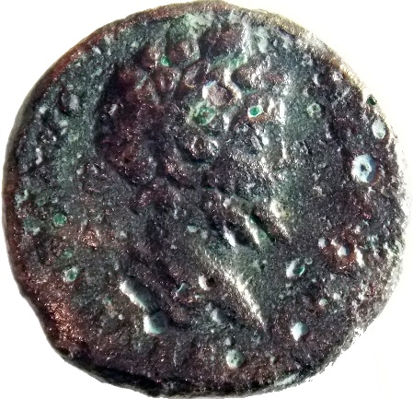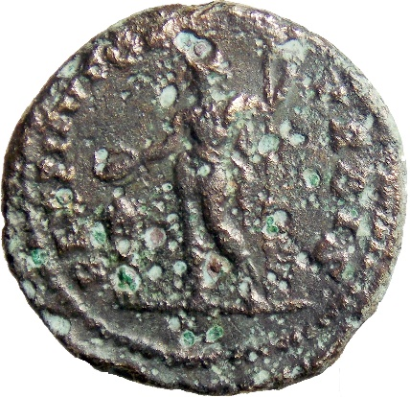
- Denomination: denarius - plated
Metal: AE
Axis: 12; D: 18.3 mm; W: 2.82 g.
Mint: uncertain
Dating: 200-201/post
Obv: legend erased
Head of Septimius Severus, laureate, right.
Rv: RESTITVTOR - VRBIS
Septimius Severus, in military attire, standing left, sacrificing out of patera in right hand over tripod and holding spear in left hand.
Catalogue: cf. RIC 167a
Context: Sutor 2022, vicus, context 1188; Area 2A; quadrant 7; second room from west; inv.no. temp. SF 1205; 24.10.2022. Phase II.1

SEPTIMIUS SEVERUS

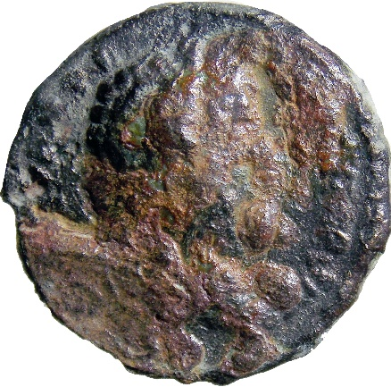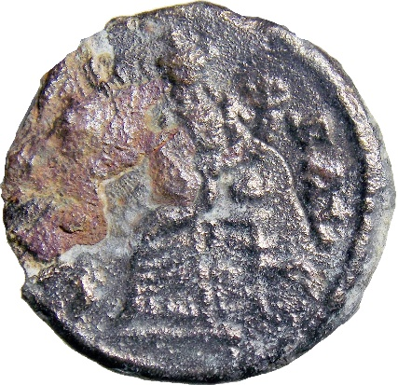
- Denomination: denarius - plated
Metal: AR+AE
Axis: 6; D: 16.7 mm; W: 1.89 g.
Mint: uncertain
Dating: 196-197/post
Obv: [l sept sev pert aug] I[m]P VIII
Head of Septimius Severus, laureate, right.
Rv: [fortuna]E AVG[g]: Fortuna, draped, seated left on low seat, holding rudder set on
globe in right hand and cornucopiae in left hand; under seat, wheel.
Catalogue: cf. RIC 77
Context: Sutor 2022, vicus, context 1188; Area 2B; quadrant E5; topographic no. 355; inv.no. temp. SF 107; 05.07.2022. Phase II.1

SEPTIMIUS SEVERUS

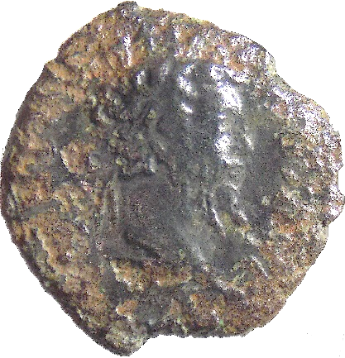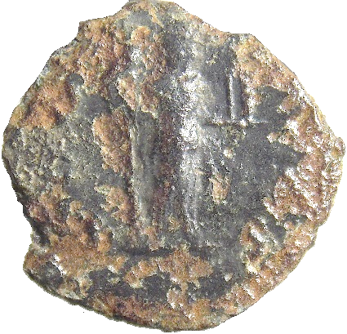
- Denomination: denarius – plated - hybrid
Metal: AR+AE; fragmentary
Axis: 10; D: -; W: 2.46 g.
Mint: uncertain
Dating: 200-202/post
Obv: legend erased
Head of Septimius Severus, laureate, right.
Rv: [n]O[bilitas]?
Nobilitas, draped, standing right, holding sceptre in right hand and palladium in extended left hand.
Catalogue: cf. RIC 13a for revers (Geta)
Context: Sutor 2022, vicus; context 1188; Area 2A; top soil; inv.no. temp. SF 701; 29.08.2022. Phase II.1

SEPTIMIUS SEVERUS

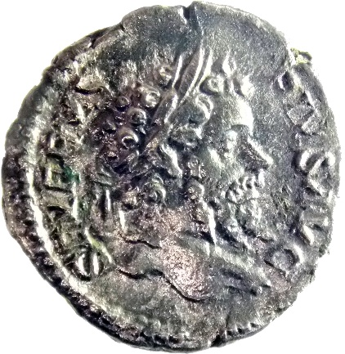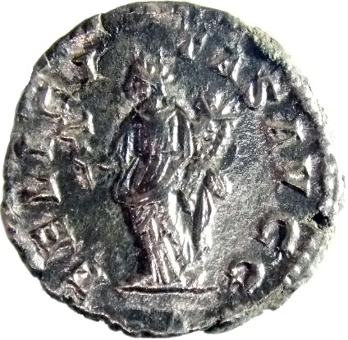
- Denomination: denarius
Metal: AR
Axis: 7; D: 18.4 x 17.8 mm; W: 2.72 g.
Mint: Rome
Dating: 202-210
Obv: SEVERVS – PIVS AVG
Head of Septimius Severus, laureate, right.
Rv: FELICI-TAS AVGG
Felicitas, draped, standing left, holding caduceus in right hand and cornucopiae in left hand.
Catalogue: RIC 261
Context: Sutor 2022, vicus, context 1188; Area 2A; quadrant 9; inv.no. temp. SF 1102; 19.10.2022. Phase II.1

SEPTIMIUS SEVERUS

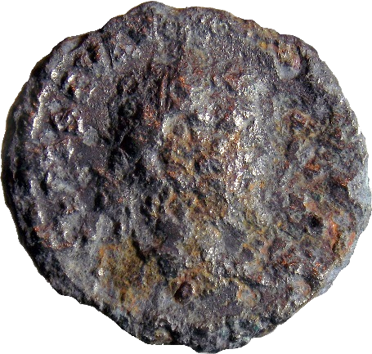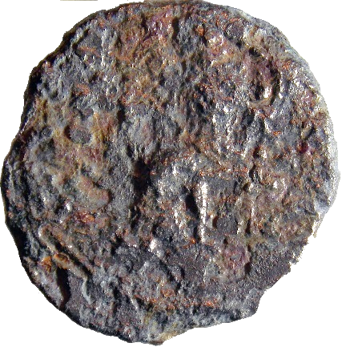
- Denomination: denarius - plated
Metal: AE
Axis: -; D: 17.7 x 16.6 mm; W: 2.16 g.
Mint: uncertain
Dating: 193-211
Obv: […] SEPT SEV AVG […]
Head of Septimius Severus, laureate, right.
Rv: legend erased
Silhouette of deity seating left.
Catalogue: -
Context: Sutor 2022, vicus, building; Area 2A/2; inv.no. temp. SF 944; 23.09.2022. Phase II.2

SEPTIMIUS SEVERUS

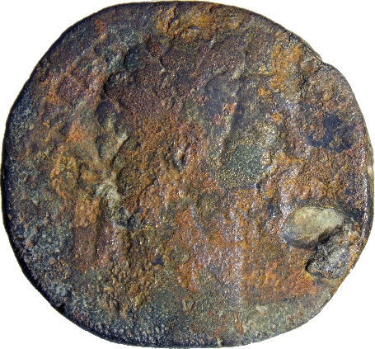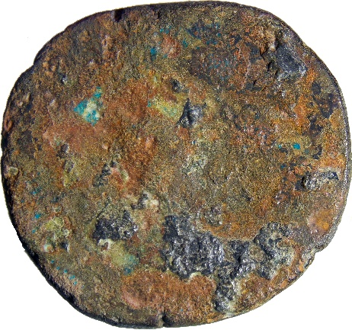
- Denomination: sestertius
Metal: AE
Axis: -; D: 24.5 x 23.3 mm; W: 11.17 g.
Mint: Rome
Dating: 193-211
Obv: […] SEPT[…]
Head of Septimius Severus, laureate, right.
Rv: erased
Catalogue: -
Context: Sutor 2022, vicus, context 1188; Area 2B, A’3; inv.no. temp. SF 438; 22.07.2022. Phase II.1

SEPTIMIUS SEVERUS: Julia Domna (Augusta)

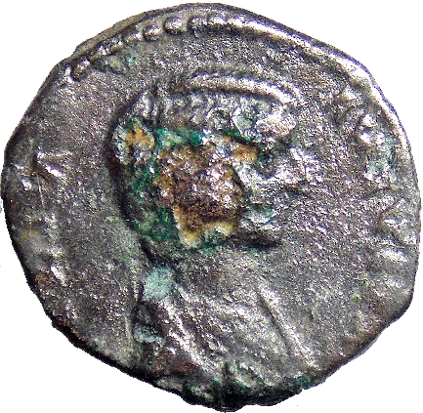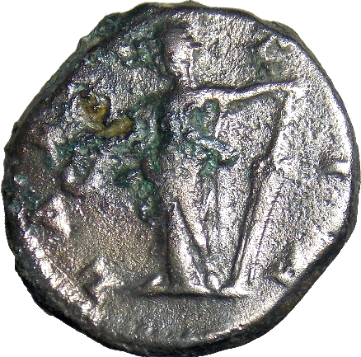
- Denomination: denarius - plated
Metal: AR+AE
Axis: 7; D: 16.7 x 15 mm; W: 2.03 g.
Mint: Laodicea ad Mare
Dating: 196-211
Obv: IVLIA – AVGV[sta]
Bust of Julia Domna, hair waved and coiled at back, draped, right.
Rv: LAE[ti]TIA
Laetitia, draped, standing left, holding wreath in extended right hand and rudder in left hand.
Catalogue: RIC 641
Context: Sutor 2022, vicus, context 1188; Area 2A; quadrant 4; inv.no. temp. SF 1042; 14.10.2022. Phase II.1

SEPTIMIUS SEVERUS: Caracalla (Caesar)

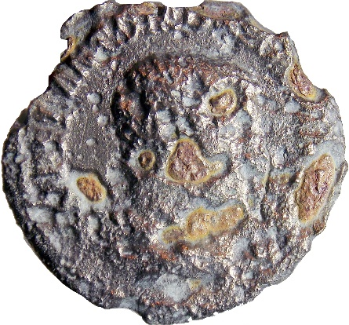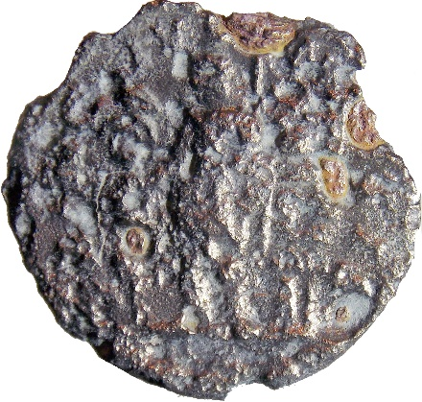
- Denomination: denarius - plated
Metal: AR + AE
Axis: 12; D: 18.6 mm; W: 2.08 g.
Mint: uncertain
Dating: 196-198/post
Obv: [m aur a]NTON CA[es pontif]
Bust of Caracalla, bare-headed, draped, right.
Rv: [pri]NC[ipi ivventu]TIS
Caracalla, in military attire, standing left, holding baton in right hand and spear in left hand; to right, trophy.
Catalogue: cf. RIC 13A
Context: Sutor 2022, vicus, context 1188; Area 2A, quadrant 4; inv.no. temp. SF 1043; 14.10.2022. Phase II.1

CARACALLA

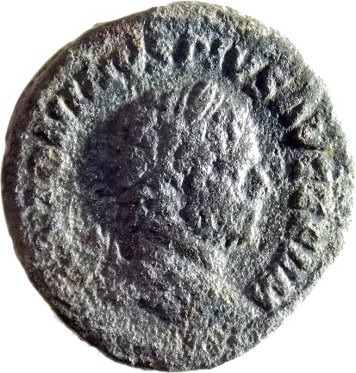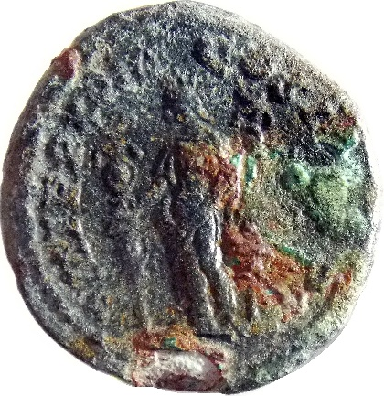
- Denomination: denarius - plated
Metal: AR+AE
Axis: 6; D: 19.1 mm; W: 3.07 g.
Mint: uncertain
Dating: 215/post
Obv: ANTONINVS PIVS AVG GERM
Head of Caracalla, laureate, right.
Rv: P M TR P XVIII COS I[iii p p]
Fides Militum, draped, standing left, holding a standard in each hand.
Catalogue: cf. RIC 266
Context: Sutor 2022, vicus, context 1188; Area 2A, quadrant 11; outside building, near the kiln; inv.no. temp. SF 1276; 28.10.2022. Phase II.1

SEVERUS ALEXANDER

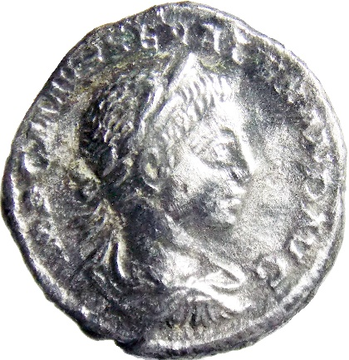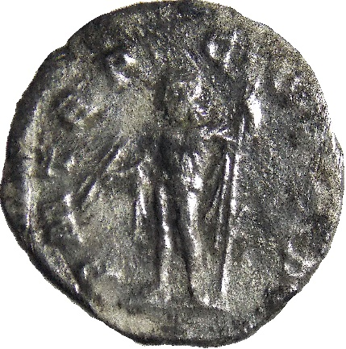
- Denomination: denarius
Metal: AR
Axis: 6; D: 18.4 mm; W: 2.94 g.
Mint: Rome
Dating: 222
Obv: IMP CAES M AVR SEV ALEXAND AVG
Bust of Severus Alexander, laureate, draped and cuirassed, right.
Rv: P M TR P – C-O[s p] P
Jupiter, cloak behind and over right arm, standing left, holding thunderbolt in right hand and sceptre in left hand.
Catalogue: RIC 5d
Context: Sutor 2022, vicus, context 1188; Area 2A, quadrant 4; inv.no. temp. SF 1049; 14.10.2022. Phase II.2

SEVERUS ALEXANDER

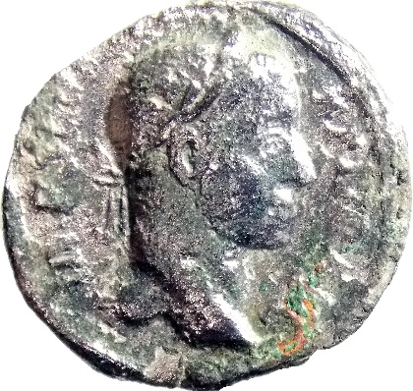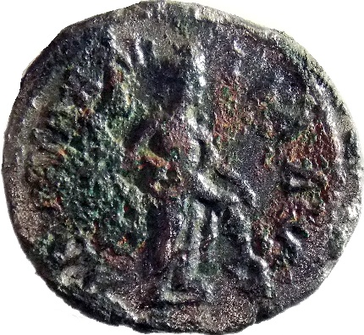
- Denomination: denarius
Metal: AR
Axis: 1; D: 18.8 x 17.3 mm; W: 2.86 g.
Mint: Rome
Dating: 228-231
Obv: IMP [sev] ALE-XAND AVG
Head of Severus Alexander, laureate, right.
Rv: [abund]AN-TIA AVG
Abundantia, draped, standing right, emptying cornucopiae with both hands.
Catalogue: RIC 184a
Context: Sutor 2022, vicus, context 1188; Area 2A, quadrant 8; inv.no. temp. SF 1073; 18.10.2022. Phase II.2

SEVERUS ALEXANDER

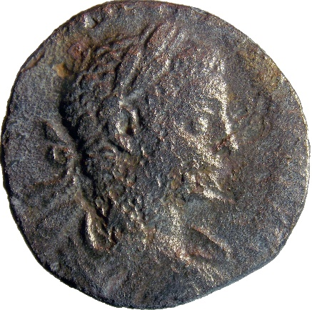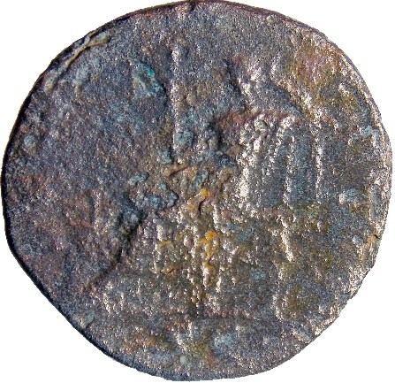
- Denomination: as
Metal: AE
Axis: 12; D: 22 mm; W: 4.46 g.
Mint: Rome
Dating: 222-231
Obv: [imp caes m aur sev alex]AND[er aug]
Bust of Severus Alexander, laureate, draped, right.
Rv: SEC[uritas perpetua]; in exergue: S C
Securitas, draped, seated left, by lighted altar, holding sceptre in right hand and supporting head with left hand.
Catalogue: RIC 613c
Context: Sutor 2022, vicus, context 1188; Area 2A, quadrant 12; inv.no. temp. SF 1103; 19.10.2022. Phase II.2

SEVERUS ALEXANDER

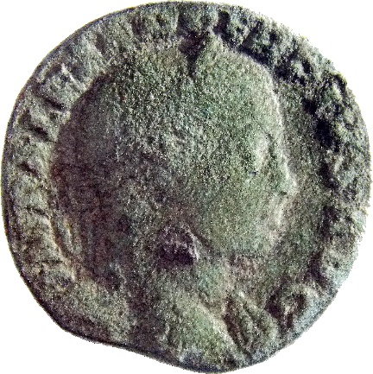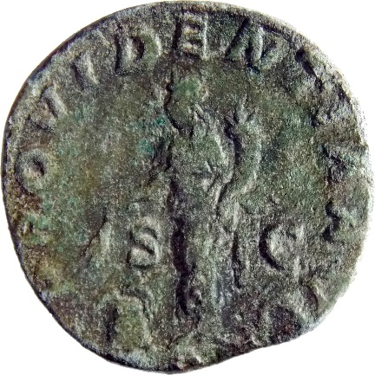
- Denomination: sestertius
Metal: AE
Axis: 12; D: 27.5 x 26.8 mm; W: 15.03 g.
Mint: Rome
Dating: 231-235
Obv: IMP ALEXANDER PIVS AVG
Bust of Severus Alexander, laureate, draped over left shoulder, right.
Rv: PROVIDENTIA AVG; in field: S - C
Providentia, draped, standing front, head left, holding two corn-ears in right hand over modius and cornucopiae in left hand.
Catalogue: RIC 648b
Context: Sutor 2022, vicus, context 1188; Area 2A, quadrant 7; room 9, beneath the tiles’ debris; inv.no. temp. SF 1245; 27.10.2022. Phase II.2

SEVERUS ALEXANDER

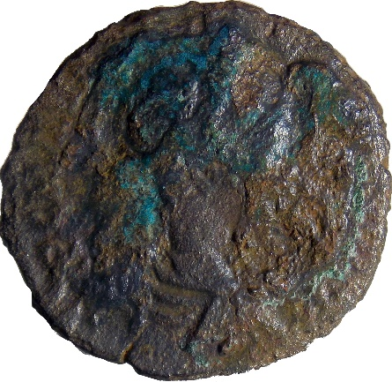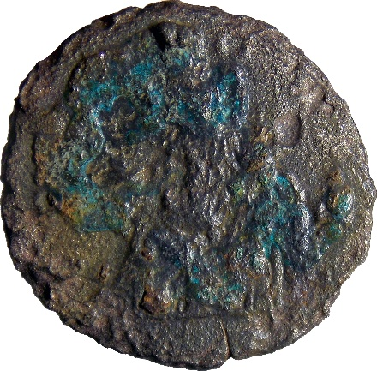
- Denomination: denarius - plated
Metal: AE
Axis: 12; D: 17.8 x 16.9 mm; W: 1.69 g.
Mint: uncertain
Dating: 222-235
Obv: IMP C M AVR [sev alexand aug]
Bust of Severus Alexander, laureate, draped, right.
Rv: C[oncordi]A
Concordia, draped, seated left, holding patera in right hand and cornucopiae in left hand.
Catalogue: RIC 275d
Context: Sutor 2022, vicus, context 1188; Area 2B, quadrant B1; inv.no. temp. SF 447; 22.07.2022. Phase II.2

GORDIANUS III

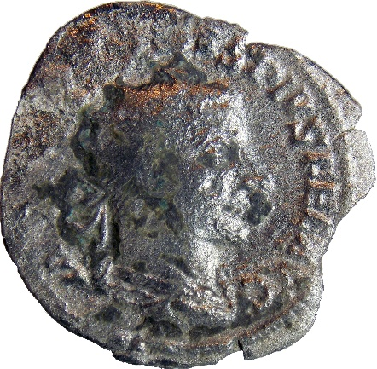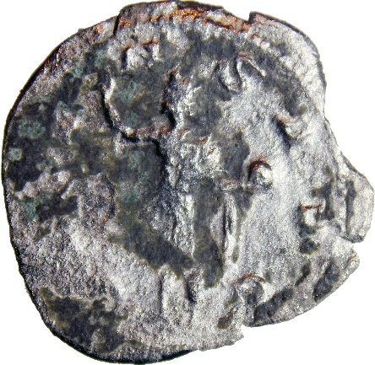
- Denomination: antoninianus
Metal: AR
Axis: 5; D: 23.7 mm; W: 2.14 g.
Mint: Rome
Dating: 242-244
Obv: [imp gordian]VS PIVS FEL AVG
Bust of Gordian III, radiate, cuirassed, seen from behind, right.
Rv: [orie]-NS AVG
Sol, radiate, nude except for cloak around shoulders, standing left, raising right hand and holding globe in left hand.
Catalogue: RIC 213
Context: Sutor 2022, vicus, context 1188; Area 2A, quadrant 7; found in the second room from west; inv.no. temp. SF 1202; 24.10.2022. Phase II.2

GORDIAN III

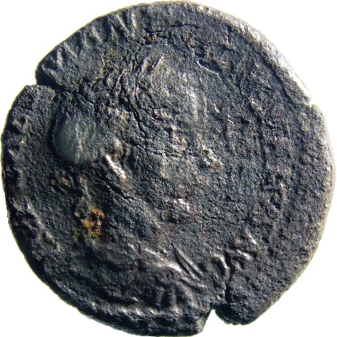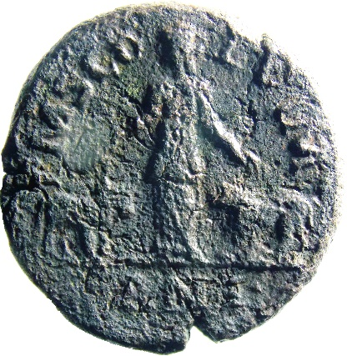
- Denomination: sestertius
Metal: AE
Axis: 12; D: 29.5 mm; W: 19.48 g.
Mint: Viminacium
Dating: 239-240
Obv: [imp caes] M ANT [gordia]NVS AVG
Bust of Gordian III, laureate, draped and cuirassed, right.
Rv: P M S CO-L VIM
Exergue: AN • I •
Moesia standing front, head to left, extending her hands to bull and lion standing on either side.
Catalogue: Martin 1.05.1
Context: Sutor 2022, vicus, context 1188; Area 2A, C7, big room, near W profile; inv.no. temp. SF 1173; 22.10.2022. Phase II.2

PHILIP I

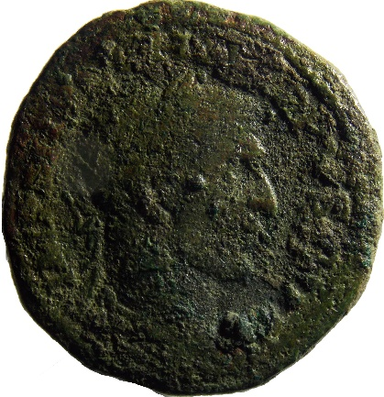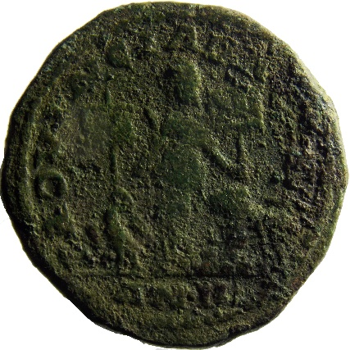
- Denomination: sestertius
Metal: AE
Axis: 7; D: 29.1 x 27.4 mm; W: 15.18 g.
Mint: Ulpia Traiana Sarmizegetusa
Dating: 247-248
Obv: IMP M IVL PHILIPPVS AVG
Head of Philip I, laureate, right.
Rv: PROVINC[ia dacia]
Exergue: AN • II •
Dacia standing between eagle and lion, holding standards inscribed V and XIII.
Catalogue: Martin 2.57.1
Context: Sutor 2001, vicus; Area 2; excavated ground; 05.10.2001. Phase II.2

PHILIP I

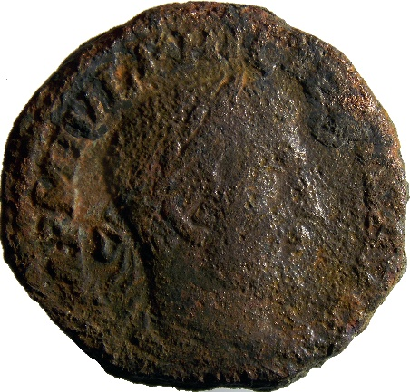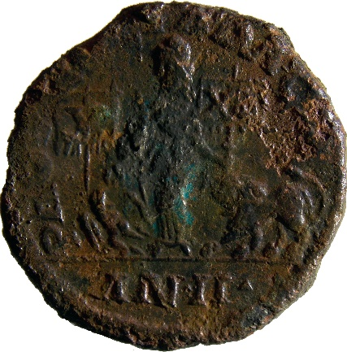
- Denomination: sestertius
Metal: AE
Axis: 7; D: 26.3 x 25.4 mm; W: 13.37 g.
Mint: Ulpia Traiana Sarmizegetusa
Dating: 247-248
Obv: [i]MP M IVL PHI[lippus] AVG
Head of Philip I, laureate, right.
Rv: PROVINCIA DACIA
Exergue: AN • II •
Dacia standing between eagle and lion, holding standards inscribed V and XIII.
Catalogue: Martin 2.57.1
Context: Sutor 2022, vicus, context 1188; Area 2, C8, inside big room, near the N wall; inv.no. temp. SF 1146; 21.10.2022. Phase II.2

PHILIP I: Otacilia Severa (Augusta)

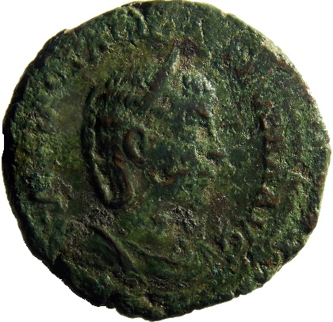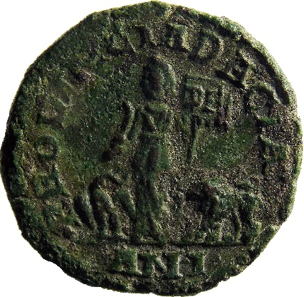
- Denomination: sestertius
Metal: AE
Axis: 1; D: 29.4 x 29.1 mm; W: 16.07 g.
Mint: Ulpia Traiana Sarmizegetusa
Dating: 246-247
Obv: [marci]A OTA[cil sev]ERA AVG
Bust of Otacilia Severa, diademed, draped, right.
Rv: PROVINCIA DACIA
Exergue: AN • I •
Dacia standing facing, head left, holding curved sword and vexillum inscribed D F; at feet to left, eagle standing left, head right, with wings displayed, holding wreath in beak; to right, lion standing left.
Catalogue: Martin 2.69.1
Context: Sutor 2001, vicus; trench 3; m 17-18; depth -1 m. Phase II.2

TRAJAN DECIUS: Herennia Etruscilla (Augusta)

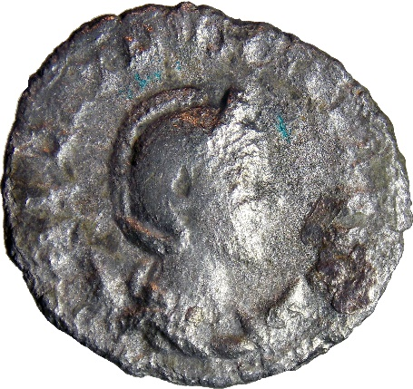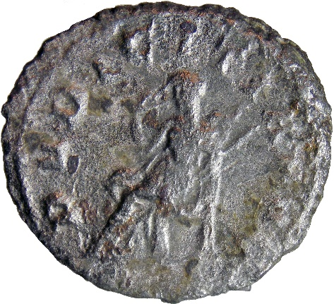
- Denomination: antoninianus
Metal: AR
Axis: 12; D: 22 x 20 mm; W: 3.34 g.
Mint: Rome
Dating: 249-251
Obv: [her] ETR[uscilla aug]
Type: Bust of Herennia Etruscilla, diademed, draped, on crescent, right.
Rv: PVDICITIA AVGG
Pudicitia, draped, veiled, seated left, drawing veil with right hand, holding sceptre in left hand.
Catalogue: RIC 60
Context: Sutor 2022, vicus, context 1188; Area 2A, C8, metal detecting; inv.no. temp. SF 1135; 20.10.2022. Phase II.2

