ARCHAEOLOGICAL WORKS IN THE LAND OF LĂPUȘ

Marta Ioana Moldoveanu
University Babeș-Bolyai of Cluj-Napoca
marta_moldoveanu@yahoo.com
Paul Popa
University Babeș-Bolyai of Cluj-Napoca
paul.p.popa@gmail.com
Daniela Lucia Manea
Technical University of Cluj-Napoca
daniela.manea@ccm.utcluj.ro.

Abstract: Over time many lands emerged across the Romanian territories where undeniable cultural characteristics stood the test of time. To some extent, the specific or general culture, habits and traditions which complete the Romanian cultural heritage were set apart by the various geographical areas and landforms. It is absolutely vital and imperative to unearth, preserve and promote the cultural values of each land, in particular of the Land of Lăpuș. Their diversity calls for more and unabated attention to how they have become an integral part of the dynamics of rural development and highlights the importance of such an environment and of its conservation against any changes which might erode the very cultural fabric of the areas.

Keywords: the land of Lăpuș, archaeological site, findings, historical cultural landscape, building materials

INTRODUCTION
The need of an ongoing analysis into the details of the cultural landscapes in the Land of Lăpuș led us to take actions which are intent to expose the unique way in which these places, traditions and values showcase our past, teach us who we currently are, and predict above all else the manner in which they are due to evolve and introduce our identity to every new generation. Our role is to permanently reveal and highlight our values, how they have shaped our present and how they should be observed, promoted and nurtured in the future. For this reason, research papers should focus on relentlessly capturing the dynamics and progression of culture.
In 1972, the Convention concerning the Protection of the World Cultural and Natural Heritage thought to define cultural heritage as follows: "cultural heritage": monuments, architectural works, works of monumental sculpture and painting, elements or structures of an archaeological nature, inscriptions, cave dwellings and combinations of features, which are of outstanding universal value from the point of view of history, art or science; groups of buildings: groups of separate or connected buildings which, because of their architecture, their homogeneity or their place in the landscape, are of outstanding universal value from the point of view of history, art or science. And sites: works of man or the combined works of nature and man, and areas including archaeological sites which are of outstanding universal value from the historical, aesthetic, ethnological or anthropological point of view.
Many definitions and theories emerged over time regarding the features of historical landscapes, but they generally refer to the space and time elements which suggest human intervention aimed at “making the place favourable” so that it meets the basic human needs of security and protection. They fall into seven subtypes, of which archaeological sites is the most important. They represent “the mirror of past habitats” and are of a genuine historical interest precisely because finding and examining them involves “digging them out from under the ground”. Citadels are the second subtype, as they are the first constructions erected by man for defence purposes, with curtain walls, bastions or towers and access gates as their main features.
Another element of the historical cultural landscape is represented by Roman camps used as defence and fortification structures specific to the former Roman provinces. Castles, meant to defend the lord`s family, could be summer or winter retreats, exhibiting lush architecture, with a keep and adorned with towers, turrets, battlements, etc. The forts, are yet another component of the historical landscape typical of the colonial period, more commonly met as larger and larger parts of native lands were being conquered, and fortifications consisting of moats and ramparts erected for defence purposes. Palaces are stately works, massive and sophisticated exhibiting associated and subordinate features (gardens, fountains, walls, etc.).

STUDY AREA
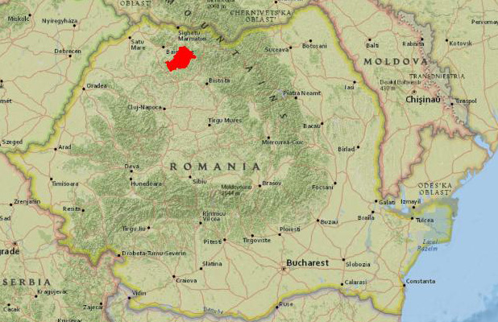
Romania is home to many elements of this historical cultural landscape, from archaeological sites scattered across the country, to citadels, Roman camps or castles. They serve a functional purpose and are only to be interpreted in relation to the time of construction, as the time dimension is the one which gives a landscape its historical value. Despite the classifications of historical landscapes based on the historical periods from which the landscape components originate, the intrinsic symbolism and meaning of the cultural remains prevail. I wish to present below one of the specific elements found in the Land of Lăpuș, namely the large archaeological site of Suciu de Sus.
Fig. 1 Land of Lăpuș Framing area

Without insisting further on details around the historical components in the Land of Lăpuş mentioned above, I must note that what could be one of the most important sites, a Late Bronze Age cemetery, was discovered in the area. The digs started in the 1960s in the area called Podanc. The rituals performed at the site involved cremations and offerings, and resulted in carbonised wood constructions and some ceramic objects. The wood constructions included both structural poles and decorative elements. The potsherds came from ritual vessels with offerings to honour the deceased. The ditches at the site, the variations in the surface, the ledges, the layers of fragments, the ash, and the wall cover a span between Culmea Preluca towards Șatra Pintii, Minghet, Hudin, Țibleș and prove that the sacred place was used by several generations. Initially 80 tumuli scattered over one kilometre were discovered. The area of the archaeological site proved to be considerable so the digs continued to reach a significant scale. That resulted in several finds being discovered, the area being divided into several sites based on the new archaeological elements, besides the burial ground, found, such as dwellings and occupations, etc.

MATERIALS AND METHODS
This written article addressed several types of materials and combined several types of methodologies. Thus, the materials employed were diverse. Articles on both historical constructions and geographical were taken into consideration. The research, required a thorough analysis of all documents in order to produce solid and useful conclusions.
The methodology employed proposed a search of the literature both offline and online from January 2018 until the current date. Articles, books and different papers on the required fields were very useful in our research.

RESULTS AND DISCUSSION
Channelled pottery ware has been found at Suciu de Sus, in the Obreja Valley, in the Grădina Floarei Zesuchii, and a few Bronze Age ceramic objects have been identified in Vârful Dâmbului, south of the Mărioarei lui Daneliuc. The hilly area of Țibleș, the place called Tăușor has revealed other ceramic artefacts. A deposit of bronzes has been discovered in both Coțofeni and Lăpuș. An ancient human settlement has been found in Ograde, dated after the second phase of the Lăpuș necropolis. Botul Troianului, on the northen extremity of Troian, has unveiled a deposit of bronzes, consisting of 10-15 complete belts, decorated with lines, and also a tumulus cemetery from the Bronze Age, identical to the ones discovered at Valea Groșilor and Șesu. A few small mounds have been discovered in Paltin, near the Minghet Valley thought to be burial barrows. At the Ponorul Jitelor Cave with a large number of tunnels, most likely used by humans, and at the border crossings of Arșița, La Gruimane, Obcina Lespezilor, Poderei, Pusta there may be “a plateau with the remains of a wall, weapons and bronze implements”. A human settlement lies in Izvorâște, Gura Boii, Muncei, Suciu de Sus or Lăpuș, and Grădina Curții is home to bronze objects. Atypical pottery ware has been discovered in Pleșa, and also a stone axe, and channelled pottery ware has been found at the Poduri site. A cemetery has been discovered in Poduri pe Coastă, flanked by burnt slate tiles. The cemetery belongs to the second phase of the Suciu de Sus culture, at the beginning of the Bronze Age. Pottery ware, pots, cups, etc. have been unearthed in La Șes.
Stone objects (axe), and also pottery has been uncovered in the Târgu Lăpuș area, and in the Valea Mănăstirii region there are rumours that an old monastery existed. The site currently features a mound and a stone cross. In the same region the remains of a stone church, from the 18th century have been discovered, and the border crossings of Obreja Văii Tâlharului and Obreja Văii Rusului, Lutărie, Pusta, Guruiețe, La Gruimane, La Temeteu, the Podinog plateau, Blidul lui Pintea, Pârâul Hârbului and the location known as Bliduț may be of archaeological interest. Pottery has been found in La Poderei and Porgolat, there are records of a Varteto (Vârful Cetății [the Citadel Peak]) location, and a few atypical pottery objects have been identified in Mormânturi. Rounded channelled pottery has been found at Șesurile Rogozului which belongs to the Late Bronze Age Lăpuș settlement. The old location of the settlement would have been at Poiana Popii which is home to archaeological sites alongside La Ciurgău, Poduri and Pusta Ienășoaiei. To the right of the Stadium street, in Întorsura or Torkolat numerous atypical channelled potsherds have been collected. Channelled pottery has also been found in Augustin Farcaș`s garden, but also in the neighbouring gardens, between Valea Ursului and Valea Cuculbet, along the Mireș stream, belonging to the Lăpuș deposit. Two fired clay weights and a decorated cup have been found in Eghereș. A note from 1895 stated that weapons, pottery and jewellery have been found around the Târgu Lăpuș borough, without any details as to the whereabouts of the site where they had been discovered. They are most likely part of the Floth collection, and may be split into the Târgu Lăpuș I deposit and Târgu Lăpuș II deposit.
Around the village of Coroieni near Cheile Babei there are remains of kilns used for burning lime dated to the 20th century, and the Guruiețe, Podul Forauălor, Poduț Comorâța, În Podereiaș, Măgura, Podereiul, Podul Lacului, Bliduț, În Pietrar sites may be of archaeological interest. A Neolithic axe and a Drachm have also been found, and the ancient location of the village of Coroieni is thought to be Între Vâlcele, under the name Satul Bătrân [the Old Village] or Valea Satului celui Bătrân [The Old Village Valley], with the La Pod, Pe Pod, Pe Poduri, În Pietrar sites on the border line to be investigated for archaeological purposes. In the village of Cupșeni, at Handal and Poderei, as well as the cairns at Ciurgău, Arșița, În Pondereiu lui Leșa, La Ponderee, La Temeteu, Pusta, Pusta Nucului, În Poliță may be significant archaeological sites. A perforated Neolithic axe has been unearthed in Locul lui Idreiu lui Dămicu, and many ceramic objects, slate tiles have been found in Dâmbu Cruci, and Libotin revealed works reminiscent of a burial site. A deposit of bronzes has been discovered in Poienile Budii (axe, chain links, buttons, phalera, etc). The ancient location of the village of Cupșeni is known as Bârdoceni, and a church which has left no trace had been erected in Valea Bisericii [the Church Valley]. The border crossings Dâmbul Morților, La Podine, Măgura, Măgura cea Mare, Măgura de Sus, Măgura Mică, Podereia lui Istrate, Podereia Mare, Podurelele Mari, Vârful Bârlogului may also be of archaeological interest.
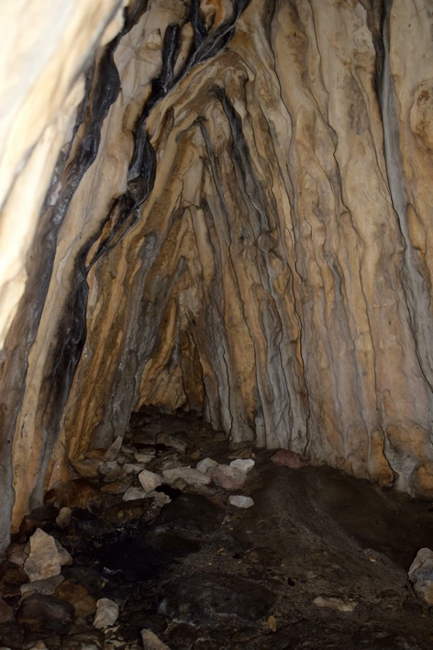
Remains of undated melting kilns have been uncovered between Băiuț and Botiza. An Alexander the Great gold Stater and a Drachm have been found in the Butuzas` garden, on the left side of the Băiuț stream. The Băiuț deposit has two main veins: Băiuț and Robu, both mining sites dating as far back as prehistoric or Roman times given the very old objects manufactured and found in the Land of Lăpuș. The most important mining activities carried over time were at Providența Divină, Borcut (the Anton, Petru and Pavel mines) Zaharia, Văratic, Cizma and Coasta Ursului. A well-known cave in the area is Peștera Casa Pintei, known as Peștera lui Pintea Viteazul [Pintea the Brave`s Cave] or Peștera din Piatra Pintii [The Cave at the Pintea Stone], the Bone Cave at Poiana Botizii, home to a deposit of animal bones, which had not however, been used as shelter by humans. Peștera de la Izbucul dintre Pietre [the Karst Fenster between the Rocks], Peștera Meduzei [the Jellyfish Cave] at Piatra Mică, Peștera tunelor suprapuse [Cave of the Stacked tunnels] at Piatra Pintii, are right next door and have yet to be studied by archaeologists.
Large amounts of glassy and glossy obsidian indicative of smelting, but also stocks of bronzes and atypical ceramics have been found around the village of Lăpuș, in several locations, such as Podanc, Tinoasa, Cioncaș, Sub cioncaș, La arini, at the site called Gruiul Târgului (Hoșporodic`s Hill), along the Iedera stream, in the Herța Valley, but also along the Cerțiu Valley, on the Drumul Colbului [Dusty Road]. A slate axe and a stone axe, most likely part of the Wietenberg Culture have also been discovered. In Podul Hotarului, but channelled and grooved potsherds belonging to the Lăpuș group have also been found at the sites of La arini, Răstoci, Tuliceasca. Bronze Age settlements have been found in Valea Cerțiului. On Mlaca or Mecra Peak, at the site called Sub Mlacă Lăpuș potsherds have been discovered, with black coarsely made pottery at Dumbrăvița. Channelled pottery has been found at the site of Tinoasa, and 26 tumuli have been discovered between Tinoasa and Podanc, Podancul Mare and Podul Hotarului which required extensive digging and led to valuable finds being unearthed. Several mounds, most likely of a burial character, have been found in Vârfu Fetii, Șurile Tomii și La piuă, as well as a deposit of bronzes in Secătura Savului (bracelets, small statues, vessels, cups, etc). The ancient location of the Lăpuș village lies somewhere around the Râoaia Valley given the ditch in the area called Pe poieni, built by using river stones and most likely serving as a rampart, while the remains of a foundry lie in Podoroi. Archaeological artefacts may lie underground at Comorâșe, Pe Grui, Handal and Podinog.
Fig. 2 The Casa Pintei Cave, courtesy of the Tourist Information Centre, Tîrgu Lăpuș
I am presenting below the names of the sites, their category, the location where they have been identified and the period they date back to. The information is provided by the National Archaeological Repository and has been supplemented by data taken from the works of the main archaeologist covering the area, Carol Kacso.

No. | Name | Category | Type | Location | Period
 | The Suciu de Sus settlement in Libotin - Podoroiul Mare, some 2 km north of the village, on the left side of the road to Ungureni, on the relatively high terrace right of the Rotunda river | Civilian occupation | Settlement | Libotin, commune of Cupșeni | The Bronze Age
 | The Suciu de Sus settlement in Libotin - Dâmbu Crucii II, some 200 m north of the village, right next to the road which connects Rogoz şi Cupşeni, on the high terrace right of the Rotunda river (Libotin), outside of the "Dâmbu Crucii I" complex | Civilian occupation | Settlement | Libotin, commune of Cupșeni | The Bronze Age
 | The Lăpuş settlement in Libotin - Dâmbu Crucii I.Some 200 m north of the village, right next to the road which connects Rogoz şi Cupşeni, on the high terrace to the right of the Rotunda river (Libotin). | Civilian occupation | Settlement and burial | Libotin, commune of Cupșeni | The Bronze Age
 | Mound from unknown period in Lăpuş - La piuă, on the terrace to the right of the Lăpuş river, close to the western extremity of the village. | funeral finding | mound | Lăpuş, commune of Lăpuş | Unstated
 | Modern blacksmith workshop at Lăpuş – Podoroi, north of the village, on the top terrace to the left of Lăpuş | construction | workshop | Lăpuş, commune of Lăpuş | Modern Era / 19th century
 | Fortification from unknown period at Lăpuş - Pe Poieni, some 2 km southeast of the Podanc terrace, in an area of relatively high hills. | fortification | rampart | Lăpuş, commune of Lăpuş | Unstated
 | Mounds from unknown period at Lăpuş - Vârful feţii, right of the Lăpuş River, to the southwest of the village, near the top of a hill dominating the landscape | funeral find | mound | Lăpuş, commune of Lăpuş | Unstated
 | The Suciu de Sus necropolis in Lăpuş - Gruiul Târgului, north of the Podanc terrace, on the right side of the Târgu Lăpuş - Băiuţ road (DJ109F), some 300 m of the southwestern extremity of the village. | funeral find | necropolis | Lăpuş, commune of Lăpuş | The Bronze Age
 | The Suciu de Sus necropolis in Lăpuş - Podanc on the western slope of the Gura Tinoasei hill, south of the Podanc terrace, on its extension and right next to the Tinoasa Valley, as well as on the Pe Mlacă hill top | funeral find | tumulus necropolis | Lăpuş, commune of Lăpuş | The Bronze Age, Neolithic Period
 | The Lăpuş settlement in Lăpuş - Cioncaş II on the slope of the Podanc terrace | occupation | Human settlement | Lăpuş, commune of Lăpuş | The Bronze Age
 | The Lăpuş settlement in Lăpuş - Tinoasa on the southwestern edge of the Podanc terrace, right of the Tinoasa Valley | occupation | settlement | Lăpuş, commune of Lăpuş | The Bronze Age
 | The Lăpuş settlement in Lăpuş - Dumbrăviţa on the high terrace, left of the Lăpuş river | occupation | Human settlement | Lăpuş, commune of Lăpuş | The Bronze Age
 | The Lăpuş settlement in Lăpuş - Sub Mlacă on the northern slope of the Pe Mlacă hill or Vârful Mecrii, situated southwest of the village, extending from the Podanc terrace. | occupation | settlement | Lăpuş, commune of Lăpuş | The Bronze Age
 | The Lăpuş settlement in Lăpuş - Valea Cerţiului some 1.5 km southeast of the village, on the high terrace left of the Cerţiu Valley, on Gh. Tomai`s land, some 200 m south of P. Muţiu`s house | occupation | Human settlement | Lăpuş, commune of Lăpuş | The Bronze Age
 | The Lăpuş settlement in Lăpuş - Tuliceasca northeast of the village | occupation | Human settlement | Lăpuş, commune of Lăpuş | The Bronze Age
 | The Lăpuş settlement in Lăpuş – Răstoci on the second terrace left of the Lăpuş river, near the mouth of the Tinoasa stream | occupation | Human settlement | Lăpuş, commune of Lăpuş | The Bronze Age
 | The Lăpuş - La Arini archaeological site, some 2 km west of the southwestern edge of the village, on the left side of the Târgu Lăpuş - Băiuţ road, right next to where the Tinoasa stream empties into the Lăpuş river | occupation | Human settlement | Lăpuş, commune of Lăpuş | The Bronze Age, Hallstatt
 | The Lăpuş settlement in Lăpuş - Podul Hotarului on the high terrace, to the left of the Lăpuş river | occupation | Human settlement | Lăpuş, commune of Lăpuş | The Bronze Age
 | The Lăpuş settlement in Lăpuş - Sub Cioncaş, some 2 km of the southwestern edge of the village, extending northwards from the Podanc terrace, near the Cioncaş site | occupation | Human settlement | Lăpuş, commune of Lăpuş | The Bronze Age
 | The Lăpuş settlement in Lăpuş – Cioncaş, some 2 km of the southwestern edge of the village, extending northwards from the Podanc terrace | occupation | Human settlement | Lăpuş, commune of Lăpuş | The Bronze Age
 | Bronze Age settlement in Groşii Ţibleşului – Tăuşor, some 6 km northeast of the village, in the piedmont of Ţibleş, east of the Minghet Valley, over 800 m high. | civilian occupation | Human settlement | Groşii Ţibleşului, commune of Groşii Ţibleşului | The Bronze Age
 | Mounds from unknown period in Groşii Ţibleşului – Paltin, near the Minghet Valley | funeral find | mounds | Groşii Ţibleşului, commune of Groşii Ţibleşului | Unstated
 | Bronze Age settlement in Groşii Ţibleşului – Ograde, some 200 m northeast of the southeastern extremity of the village, to the left of the Suciu (Ţibleş) river, where the slope of a hill rises | civilian occupation | Human settlement | Groşii Ţibleşului, commune of Groşii Ţibleşului | The Bronze Age
 | Bronze Age settlement in Groşii Ţibleşului - Vârful Dâmbului on the edge of an irrigation canal, slightly south of Daneliuc`s Mărioara place | occupation | Human settlement | Groşii Ţibleşului, commune of Groşii Ţibleşului | The Bronze Age
 | Bronze Age settlement in Groşii Ţibleşului - Valea Obrejei in Floarea Zesuchii`s garden | occupation | Human settlement | Groşii Ţibleşului, commune of Groşii Ţibleşului | The Bronze Age
 | Prehistoric settlement in Dobricu Lăpuşului | civilian occupation | Human settlement | Dobricu Lăpuşului, commune of Târgu Lăpuş Town | Prehistory
 | Hallstatt settlement in Dămăcuşeni – Poderei, some 2 km northeast of the centre of the town, on the protruding ridge of the high terrace right of the Lăpuş river | occupation | Human settlement | Dămăcuşeni, commune of Târgu Lăpuş Town | Hallstatt
 | The Suciu de Sus settlement in Dămăcuşeni – Porgolat on the high terrace to the left of the Lăpuş river, west of the town, at two sites about 100 m apart. | occupation | Human settlement | Dămăcuşeni, commune of Târgu Lăpuş Town | Unstated
 | The Suciu de Sus settlement in Dămăcuşeni - La Obreja on the eastern edge of the town, on the high terrace right of the Suciu (Ţibleş) river | civilian occupation | Human settlement | Dămăcuşeni, commune of Târgu Lăpuş Town | The Bronze Age
 | The Suciu de Sus settlement in Târgu Lăpuş – Eghereş, 500 m southeast of the town, on the terrace to the left of the Lăpuş river | civilian occupation | Human settlement | Târgu Lăpuş, commune of Târgu Lăpuş Town | The Bronze Age
 | Bronze Age settlement in Târgu Lăpuş - Întorsura. On the high terrace left of the Lăpuş river, on the eastern edge of the town, on the right side of the Stadium street | occupation | Human settlement | Târgu Lăpuş, commune of Târgu Lăpuş Town | The Bronze Age
 | Târgu Lăpuş Chalcolithic tools | isolated find | isolated item | Târgu Lăpuş, commune of Târgu Lăpuş Town | Chalcolithic
 | Bronze Age archaeological site in Suciu de Sus - Poduri pe Coastă some 750 m west of the road bridge over Ţibleş, exiting the village | occupation | occupation | Suciu De Sus, commune of Suciu De Sus | The Bronze Age
 | Bronze Age necropolis in Suciu de Sus - Troian on the high terrace, several kilometres long and several hundred meters wide, called Troian, to the left of the Suciu (Ţibleş) river, some 1.5 km northeast of the village | funeral find | cemetery | Suciu De Sus, commune of Suciu De Sus | The Bronze Age
 | Bronze Age settlement in Suciu de Jos -Pe Şes. 2 km north of the bridge over the Ţibleş, some 500 m of the southeastern extremity of the village, on the raised plain to the left of the Suciu (Ţibleş) river, along both sides of the Suciu de Sus- Groşii Ţibleşului road | civilian occupation | Human settlement | Suciu De Sus, commune of Suciu De Sus | The Bronze Age
 | Late Medieval settlement in Suciu de Jos on the high terrace to the right of the Suciu (Ţibleş) river, near the church and the school | occupation | Human settlement | Suciu De Jos, commune of Suciu De Sus | Modern Era / 18 -19th century
 | Bronze Age settlement in Suciu de Jos - Vârful Suciului, some 400 m west of the Vârful Carpănului site, on a hill top | occupation | open settlement | Suciu De Jos, commune of Suciu De Sus | The Bronze Age
 | Bronze Age necropolis in Suciu de Jos - Troian on the high terrace to the left of the Suciu (Ţibleş) river, some 1.5 km northeast of the village (Troian I) | funeral find | necropolis | Suciu De Jos, commune of Suciu De Sus | The Bronze Age
 | Bronze Age settlement in Suciu de Jos - La Şes. Some 500 m of the southeast extremity of the village, on the raised plain left of the Suciu (Ţibleş) river, along both sides of the Suciu de Sus- Groşii Ţibleşului road | occupation | Human settlement | Suciu De Jos, commune of Suciu De Sus | The Bronze Age
 | Bronze Age settlement in Suciu de Jos - Pe rât. | occupation | Human settlement | Suciu De Jos, commune of Suciu De Sus | The Bronze Age
 | Bronze Age necropolis in Suciu de Jos - Poduri pe Coastă, northeast of the village, to the right of the Suciu (Ţibleş) river | funeral find | necropolis | Suciu De Jos, commune of Suciu De Sus | The Bronze Age
 | Bronze Age settlement in Suciu de Jos – Poduri, near the old Jewish cemetery | occupation | Human settlement | Suciu De Jos, commune of Suciu De Sus | The Bronze Age
 | Prehistoric settlement in Suciu de Jos - Pleşa | occupation | Human settlement | Suciu De Jos, commune of Suciu De Sus | Prehistory
 | Bronze Age settlement in Suciu de Jos – Muncei, some 500 m of the southern extremity of the village and 300 m of the Izvorâşte site, on the high terrace to the right of the Suciu (Ţibleş) river | occupation | Human settlement | Suciu De Jos, commune of Suciu De Sus | The Bronze Age
 | Bronze Age settlement in Suciu de Jos - Gura Boii. in the centre of the village, near the left bank of the Suciu (Ţibleş) river, on the river-facing eastern slope of the hill called Gura Boii | civilian occupation | Human settlement | Suciu De Jos, commune of Suciu De Sus | The Bronze Age
 | Bronze Age settlement in Suciu de Jos - Izvorişte. On the southeastern edge of the village, on the relatively low terrace to the right of the Suciu (Ţibleş) river | civilian occupation | Human settlement | Suciu De Jos, commune of  Suciu De Sus | The Bronze Age
 | The Rohia - Poderei archaeological site on the northeastern edge of the village, on the higher ground of the Rohia Valley terrace, very close to the last households | occupation | Human settlement | Rohia, commune of Târgu Lăpuş Town | Roman Period, the Bronze Age/ 3rd - 4th century
 | The Bronze Age settlement in Rogoz - Şesurile Rogozului, some 1.5 km of the eastern edge of the village, on the terrace to the left of the Lãpuş river and to the left of the Valea Hotarului stream | occupation | Human settlement | Rogoz, commune of Târgu Lăpuş Town | The Bronze Age
Table 1 Sites in the Land of Lăpuș– courtesy of the National Archaeological Repository and of C. Kacso.

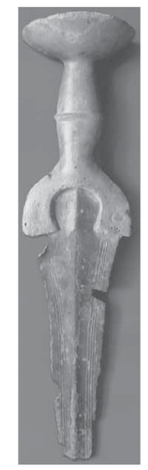
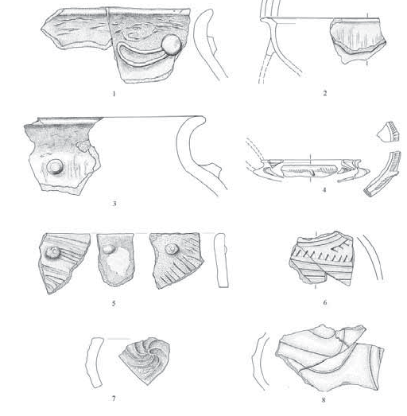
After conducting analyses and research, it was found that some of the objects discovered and identified predated the 13th century B.C.
Fig. 3 Objects identified following archaeological digs, courtesy of C. Kacso

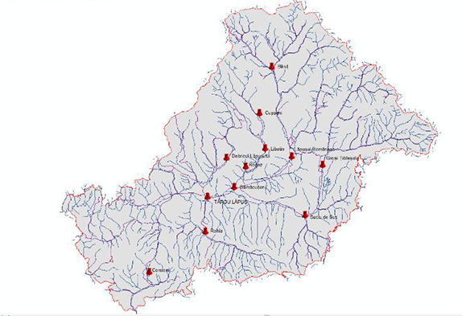
Fig. 4 Archaeological sites in the Land of Lăpuș

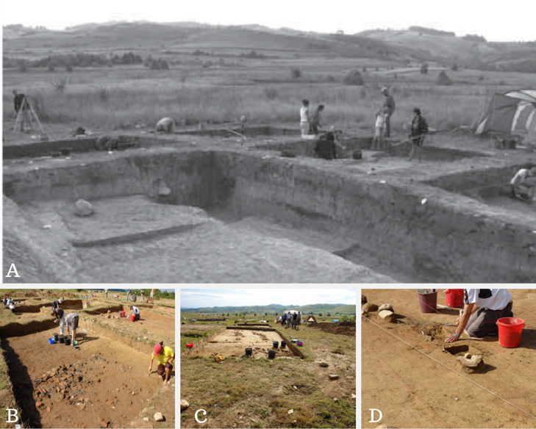

Fig. 5 The Suciu de Sus Archaeological Site – inside barrow 26, courtesy of C. Kacso

As previously shown, tumuli and necropoles have been found. They are part of old settlements, some of them pre-Christian and which have only been discovered following past and ongoing archaeological excavations. The barrows lie in areas where archaeological research is ongoing and contribute their ancient spiritual rites to complete the sacred landscape which proves once more the unique character and value of the Lăpuș zone.

CONCLUSIONS
It falls upon the inhabitants of the area first and foremost to promote history-rich regions, but also on their visitors. No action, however, to highlight and assess how they are developed and preserved can take place without researchers` support and capabilities. All these steps must observe applicable and statutory national and European standards, and above all they must be taken with caution so that the development of the areas is in full accordance with existing values and traditions. This means that all works to rehabilitate and adjust them to the infrastructure projects of rural and regional development must make their conservation a priority. It is only by preserving them that we can resurface the cultural history of areas full of potential.

REFERENCES

COCEAN/DAVID 2014
Cocean P., David N., Peisaje culturale, Editura Risoprint, Cluj-Napoca.

GOJA 2014

Goja L. P., Zona Lăpuș: În situl neolitic Podanc și lacurile Zâmbrița
http://turismmaramures.ro/zona-lapus-situl-neolitic-podanc-si-lacurile-zambrita/ (accessed on 23.02.2018).

KACSÓ/METZNER-NEBELSICK/NEBELSICK 2011
Kacsó C., Metzner-Nebelsick C., Nebelsick L., New York at the late bronze age tumulus cemetery of Lăpuş in Romania, Ancestral Landscapes, TMO 61, Maison de l’Orient et de la Méditerranée, Lyon

KACSO 2011
Kacso C. Repertoriul Arheologic al județului Maramureș, vol. 1, Editura Eurotip, Baia Mare

THE NATIONAL ARCHAEOLOGICAL REPOSITORY
N.A.R., Archaeological Sites in the Land of Lăpuș at http://ran.cimec.ro/ (accessed on 23.02.2018).

UNESCO
UNESCO, http://whc.unesco.org/en/conventiontext/ (accessed on 23.02.2018).

For more details see UNESCO, http://whc.unesco.org/en/conventiontext/
COCEAN/ DAVID 2014, 118-123.
COCEAN/ DAVID 2014, 124-129.
GOJA, 2014.
KACSO 2011, 514-517.
KACSO 2011, 547-554.
KACSO 2011, 518-525.
KACSO 2011, 211-215.
Kacso 2011, 311-316.
For more details see The National Archaeological Repository, Archeological Sites in the Land of Lăpuș at http://ran.cimec.ro/
For more details see The National Archaeological Repository, Archaeological Sites in the Land of Lăpuș at http://ran.cimec.ro/
KACSO/METZNER-NEBELSICK/NEBELSICK 2011

