Investigation and study of the findings from the rescue excavation in Sari Gol Crypt and Graveyard, North Khorasan province

Abstract
Graveyards are one of the most important archeological sources for studying past humans, which give us information about the material and spiritual cultures of different folks and human groups that lived in the past. One of these graveyards is the Sari Gol Graveyard, located 900 meters southeast of Doulân village in Râz and Jargalân city in the North Khorasan province. This graveyard in the Chandir Dam basin was explored in 2017 to save it. Excavation revealed that there is a two-story Crypt in this cemetery. Its basement part was used as a Crypt, and a room was also on top of the basement. Ten adults and two children were buried in this Crypt, and based on the available evidence, it is clear that these bodies were not buried in the Crypt. However, maybe they were placed on the Crypt floor, and the decomposing of the body was done outside the ground but inside the roofed Crypt. In addition, six graves were also explored around this Crypt, belonging to children and adults. Unfortunately, the skeletons inside these graves have been damaged due to environmental factors such as humidity and plant roots. However, the evidence shows that some people buried in this graveyard have experienced severe physical and work pressures. Also, the evidence from children's graves shows that the children's death is most likely due to an acute illness (such as infectious diseases) among them, a low level of hygiene, and a decrease in their health in this site.
Keywords: Rescue excavation, Sari Gol graveyard, North Khorasan, Northeast of Iran.
Introduction
Burial practices as an archaeological source contain diverse information. Since burials represent a stable system, reconstructing burial practices allows one to gain information about burials. Over time, different religious views concerning the soul's continued existence or complete perdition after death have played a decisive role in handling and burying the deceased. These views have been critical in deciding how to dispose of the remains of the dead.
Alekshinet and his colleague's state that, in general, six sections of archaeological information can be identified in a burial. In the first part, the ancestors' opinions about the grave goods and burials are presented, which reveals the deceased's passage to the other world and living in the realm of the dead. The second part provides the possibility of reconstructing the replacement process of an archaeological culture with another through migration or cultural exchange. The third part can be used to conclude social status, different age groups, and gender groups in ancient societies. The fourth part allows one to determine the social differentiation of ancient societies, as many features of the burial ritual were determined by the deceased's social rank. The fifth part provides information on the way family forms evolved in ancient societies and allows the identification of "outsiders" in the society to which the cemetery belongs. The presence of "outsiders" can be explained in terms of intermarriage with neighboring communities. The sixth part includes demographic factors such as longevity, nutrition, height, diseases, and traumas. Therefore, graveyards and burials are rich sources of historical and cultural, sociological, demographic, religious, and eschatological information in ancient societies and even their values. In addition, human skeletons obtained from archaeological excavations can also provide helpful information about the environment, people's genetic data, and others.
The Sombâr basin is one of the largest watersheds in the northeast of Iran, which in the north of the Atark basin collects a large amount of the region's waters from the Mesino highlands of the Qaraqoram desert and finally flows into the Mazandaran Sea from the common border of Iran and Turkmenistan. One of the tributaries of this river is Jargalân (Chandir), which originates from the Bâghleq region in the north of Raz city and leaves Iran in the north of Irqaye village and flows into the Sombâr River in Turkmenistan.
Chandir Reservoir Dam (also called Jargalân and Qazalbash) with a clay core is 777 meters west of Esmi village and 5 kilometers east of Yake Saud village in Jargalân district and in the northwest of North Khorasan province and Raz and Jargalân cities on the Chandir (Jargalân) River. The construction of this dam was to prevent the outflow of floods in the catchment area, prevent the damage of annual floods, provide drinking water to some downstream villages, and develop agriculture, drinking water, and water for small industries. Meanwhile, some ancient sites are located in the basin of the Chandir Dam reservoir, which needed to be excavated to save them. Based on this, the Sari Gol graveyard was selected and explored for 45 days in June 2014.
This research aims to investigate the exploration results and initial study of human skeletons resulting from rescue excavation with a descriptive-historical method. Unfortunately, there is little archaeological information not only from this site but also from contemporaneous sites. For example, are the genders of the skeletons obtained from exploring the Sari Gol site related to women or men? Is it possible to determine their approximate age and gender? Moreover, it is possible to identify the physical injuries on the skeletons before the time of death.
Geography and ecology of the region
Râz and Jargalân city is located north of the North Khorasan province and borders Turkmenistan. Raz and Jargalân city is one of the eight cities of North Khorasan province and has three parts named Jargalân, Gholaman, and Markazi. This city is located in the northernmost point of North Khorasan province and borders on the north and northeast with the Republic of Turkmenistan, on the south and west with the cities of Mane and Samalghan and a part of Golestan province, and on the east with Bojnord city. The main structure of the complications and unevenness of the land in North Khorasan province consists of two mountain ranges named Kopetdagh in the north and Aladagh in the center and south of the region. These two mountain ranges, running parallel to the northwest-southeast and, in some cases, east-west, have formed a large valley between them, which continues from Mashhad to Gorgan Plain. This valley in the east of the province is narrow at the start, and then, as it gets closer to the border of Golestan province (west), it expands and becomes wider. This city has an area of about 3200 square kilometers. It consists of various rugged regions such as mountains and hills, lowlands, valleys, and small intermountain plains, with a relative height of 1210 meters above sea level.
Due to the mountainous nature of the region, the area has relatively sufficient water resources. One of the seasonal rivers of the region, named Jolgeh, originates from the heights around Raz near the Iran-Turkmenistan border and flows in the east-west direction. This river changes its approach to the southwest near the village of Khartot and joins the Atrak River under the name Ab Khartot River. Another river in this region is Sombar, which consists of two distributaries, Chandir and Gholaman. These two distributaries originate in the highlands of Iran and eventually continue towards Turkmenistan and form the Sombar River, considered one of the distributaries of the Atrak River.
In general, North Khorasan Province is one of the cold and mountainous regions of the country. Regarding climate classification, it is considered a semi-arid and dry region, and its climate has been cold and dry. Weather conditions, soil characteristics, and the region's location have made the province suitable for agriculture.
Chandir Dam and archaeological research projects
Two archeological investigations have been carried out to identify historical and cultural monuments at risk in the reservoir of Chandir Dam, previously named Qezeldash. First, in the "Identification survey of Bojnord City" project in 2013, which was carried out under the supervision of Nowruz Rajabi, four sites: Esmi cemetery and Esmi site on the right side and south bank of Jargalân River and Titan cemetery and Titan site on the left side and north bank of the river were identified, which were related to the Islamic period. In the next step, after the dam construction on the Chandir River was confirmed, Iran's Archaeological Research Institute and the Cultural Heritage Research Institute decided to survey the dam basin systematically and intensively in a project named "Archaeological Rescue Studies of Chandir Dam." Therefore, Mohammad Javad Jafari surveyed the dam reservoir and its surroundings methodically so that no historical and cultural artifacts were overlooked.
In this survey, two other sites were identified, but on the heights and outside the dam basin, where there is a risk of building surrounding facilities in the future: the Soukh Cheshme site and Dolan site, both located on the north and left sides of the valley. Four sites were selected for partial rescue after the archeological survey of the dam basin. Esmi site's excavation and graveyard was entrusted to Norouz Rajabi and Soukh Cheshme site under the supervision of Fatemeh Farshi Jalali, the first season of which was completed in the late summer and early fall of 2016. The second excavation season in the Dolan site under the supervision of Jafari and Suokh Chashmeh under the leadership of Farshi Jalali was continued in late winter of 2016 and the early spring of 2017. In the last stage of the Chandir Dam rescue field works, the exploration of the two sites named Esmi and Sari Gol under the supervision of Norouz Rajabi and Ebrahim Roustaie Farsi was carried out from early June to mid-July 2018. Finally, in 2018, the third season of exploration of the nominal site was carried out. With these excavations, the rescue excavation project of Chandir Dam was completed.
Sari Gol site
Sari Gol graveyard (fig. 1) is 900 meters southeast of Dolan village, 500 meters from the Soukh Cheshmeh site, and 150 meters from the Yake Saud Road to Hesarcheh. The Jargalân River passes 100 meters south of this cemetery (fig. 2). This cemetery was severely damaged during excavation due to unauthorized diggings, and its surface was covered with thorn bushes and bushy plants. The surface of the site had low ridges. On the most extensive ridge, architectural works, stone slabs, and debris related to the building were seen due to the unauthorized excavations (fig. 3). In addition, this ridge has been severely damaged and eroded by natural factors such as rain, snow, floods, and others.
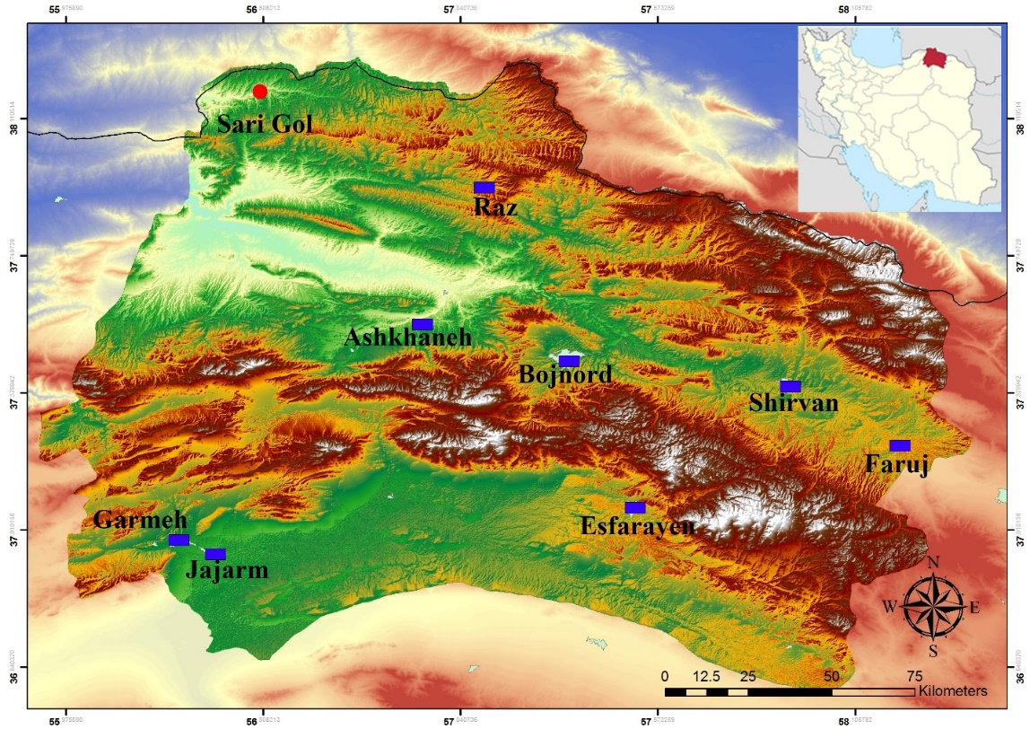
Fig. 1. the location of Raz and Jargalân city and Sari Gol site on the map
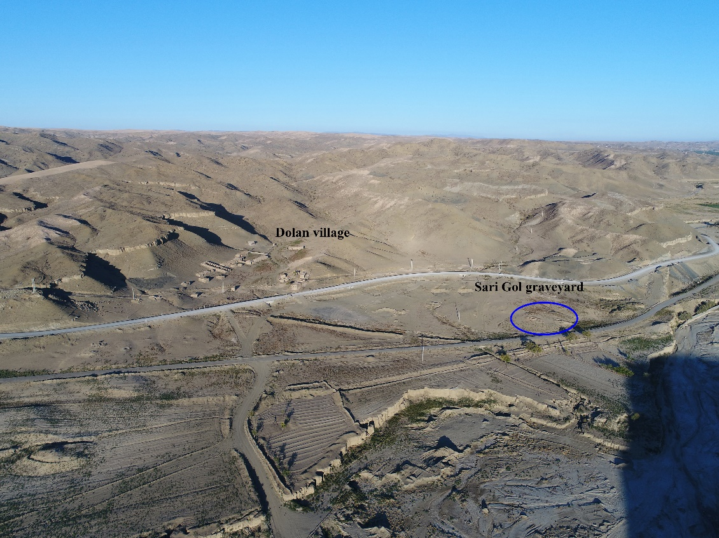
Fig. 2. The location of Chandir River and Sari Gol graveyard, view from West (after Roustaei Farsi 2017, Fig. 3)
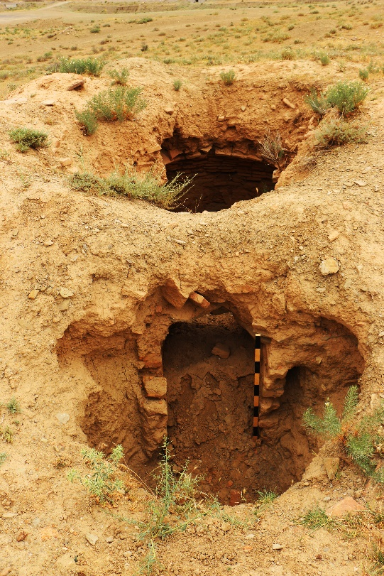
Fig. 3. unauthorized excavations in the crypt of Sari Gol (after Roustaei Farsi 2017, Fig. 4)
Excavation of the Sari Gol
The excavation in this graveyard was started to rescue and collect all remains from the building known as the Sari Gol Crypt. It continued with the aim of finding clues on the existence of other buildings or graves. In this site, three tranches were explored on the unevenness of the site's surface.
Trench 1: The first trench with dimensions of 10×7 meters was created on a mound known as Sari Gol's Crypt. The working place was finally expanded to 10 × 10 meters during the trench excavation. After cleaning the site's surface and removing its surface layers, architectural works and debris from the destruction of the walls over time were revealed. After removing the debris, a rectangular building with dimensions of 530 x 460 cm appeared. Walls were made of two rows of orangish red bricks (according to Munsell 2.5YR 7.8 Light Red2) with gray mortar (according to Munsell 5 Y 1/7 Light Gray) together. They formed a 70 cm wide wall. These walls were built on a stone foundation. The outer surface of these walls is made very irregularly, and the bricks of the walls are not aligned. Based on the findings of this excavation, it is determined that the building had two floors; the lower floor was a Crypt, and the upper floor was a room with inner walls covered with white plaster.
Also, the floor of this building has carpet bricks, and it is coated with white plaster. Many parts of its coating have been lost, and parts of its coating were found in the corners or near the walls. It seems that the upper floor was almost level with the ground or slightly higher and had a small porch in front of the entrance. The porch floor was also paved (Fig. 4-1). The longest remaining part of the walls of this chamber was only about 5 or 6 rows left, and the bricks were very rotten. Around the building and at a short distance of about one meter, a stone row was found along with rubble of bricks. It seems that a platform or a wall was built around the building, which was destroyed, and only one row of stones remained.
The building entrance door and porch are in the southern part, and the entrance to the Crypt is located strictly under the pavement of the porch. Unfortunately, its front part has been destroyed due to unauthorized digging in front of the Crypt corridor door. A narrow corridor with dimensions of 250 × 70 cm entered into the Crypt from under the porch. Stair remains indicate that the Crypt floor is lower than the corridor. It seems that this coating was also present on the floor, and unfortunately, it was utterly destroyed in the unauthorized diggings. Only a few parts remained on the side of the walls of this building, which shows that the coating applied to the plaster floor was attached to the bottom at a depth of -460 cm from the fixed point. In addition, the roof of the vaulted Crypt has been destroyed.
Unfortunately, the Crypt floor, like its roof, has been completely destroyed and overturned by unauthorized explorers, and stones, along with its debris, have been thrown inside the building. A row of stones was used for its foundation to build the wall of this Crypt, and then 15 rows of bricks have been worked on top of each other. In the construction of the wall of this Crypt, after the construction of 70 cm of the building, which is built straight and upright, the rise of the dome starts, and its arch begins (Fig. 4-2). The number of remaining bricks around this building is about 30. A sample was selected from the bricks of this unit in the western part of the Crypt to test thermoluminescence dating with the possibility of removal and the option of installing dosimeters of the analytical device above in the sampling location.
Three graves were found in this trench, and the outer part of the stones were all around and at a distance of 1 meter from the building. One of them was in the southwest corner, and two of them were in the northeast corner of the building (Fig. 5). The graves are simple pits with Lahad stone, and their direction is approximately southeast-northwest (towards Qiblah). In each of these graves, only one skeleton was found, along with them, traces of wood.
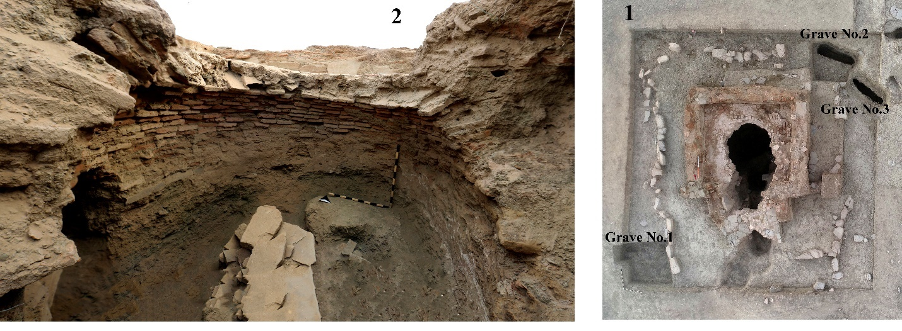
Fig. 4. 1. Sari Gol Crypt after excavation (Roustaei Farsi 2017, Fig. 49) 2. The inner part of the Crypt during the clearing of the debris resulting from demolition and unauthorized diggings (after Roustaei Farsi 2017, Fig. 28).
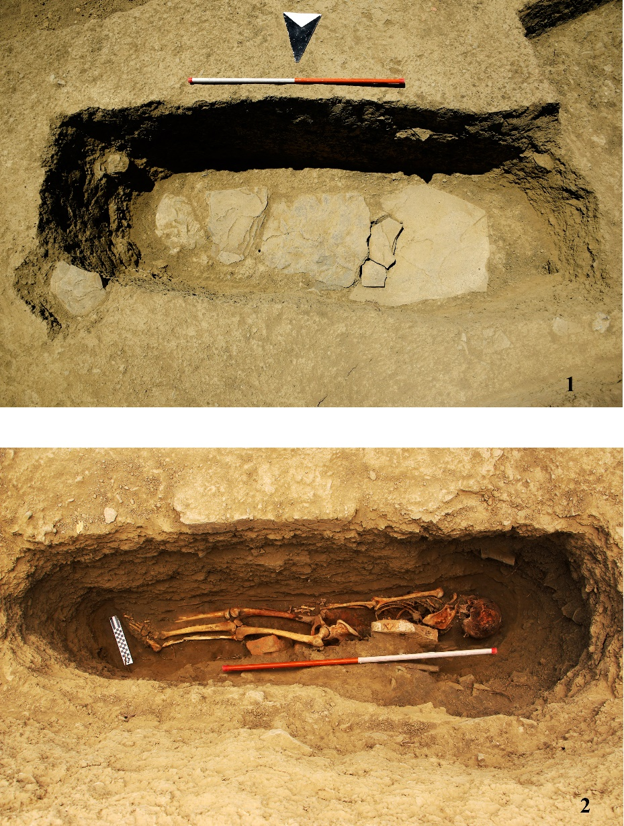
Fig. 5. 1. Grave No. 2 in Trench 1 (Roustaei Farsi, 2017: Image 52), 2. The skeleton state in Grave No. 2, Trench 1 (Roustaei Farsi, 2017: Fig. 53).
Trench 2: According to the evidence, the second trench is near the first one and on another ridge with a height of less than one meter, northeast of Trench 1 (Crypt building), with dimensions of 10 × 12 meters. This trench intended to find another building where the surface architectural remains showed signs of it (Fig. 6-1). On the surface of this ridge, there were significant, almost rectangular stone revetments. After the initial excavation, it was found that by creating this stone revetment, they separated an area containing several graves from the rest of the cemetery. A part of this stone revetment has been destroyed, and its approximate length is 610 cm in its most significant amount, and its width is 330 cm. The stone revetment was created as dry stone from a row of rubbles with 30-45 cm wide. The inner space of that stone revetment is more extended and can be seen as a ridge (Fig. 6-2). In the middle of this ridge, there is also an illegal digging hole, which is not very deep. When the surface layer of the site was explored, only a part of a skull was found next to this illegal hole, which is probably related to the grave in the same place and got destroyed. Eight graves were excavated in this trench, and no traces of burial were seen in 4 of them. It seems that these graves were prepared in advance. Burials were also found in four graves, and all of them were northwest-southeast.
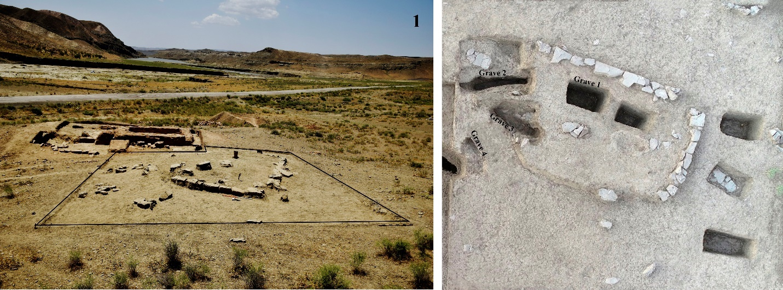
Fig. 6. 1- Trench 2 and its cairn after excavating the surface layer (after Roustaei Farsi 2017, Fig. 67), 2- Trench 2 and the position of the cairn and its graves (after Roustaei Farsi 2017, Fig.70).
Trench 3: The third trench was created and excavated 30 meters northeast of the first and second trenches with dimensions of 4 × 5 meters (Fig. 7-1). The purpose of creating the third trench was to determine the final boundaries of the cemetery site and explore more graves to obtain archaeological and anthropological data from Sari Gol cemetery and compare them with the data inside the Crypt. After exploring the surface layer of the trench and removing it, three stone revetments were found that defined the grave area and strengthened the possibility of three graves in this trench. Based on this, one of the stone revetments was excavated, and at a depth of -98 cm, the Lahad stone was identified. The burial in this grave was also done in the east-west direction and towards the Qibleh (Fig.7-2).
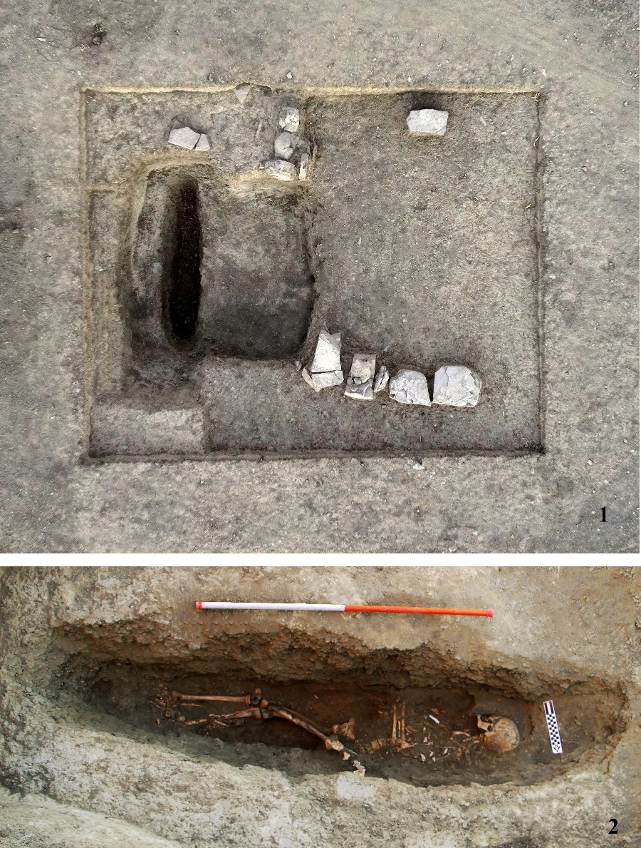
Fig.7. 1-Trench No. 3 and grave No. 1 after removing the skeleton (after Roustaei Farsi 2017, Fig. 85), 2- The same grave before removing the skeleton (after Roustaei Farsi 2017, Fig. 87)
Studying the skeletons of the graves
The depth of the graves varied from the Lahad stone to the bottom in this cemetery, and in some of them, this depth was high (between 6055 and 6055 cm). The graves' width was also very narrow (about 40 cm). Therefore, the incredible depth and narrowness of the graves and the abundance of large and small, fresh and rotten plant roots in the graves and around and inside the skeletons made the excavation conditions much more difficult. During the exploration, a soil sample was collected from the pelvic bone cavity for parasitological studies. Bone (rib) and tooth samples were also taken for isotopic tests of diet and isotopic tests of displacement/migration and carbon 14 dating. After completing the exploration of each skeleton, preparing a report, and recording anthropological information, photography of the grave and skeleton was also done, and finally, the skeleton was collected. The bones of each skeleton separately and based on the type of bone (arm, leg, rib, hip, spine, and others) and side of the body (right/left - for example, the long bones of the right hand in a bag, the long bones of the left hand in another bag, the long bones of the right leg in a separate bag) were transferred to zip-lock bags - with information about each bone, grave number, skeleton number, site name, trench, date. The skeletal remains of children who were in the adult graves were also placed in separate zip-lock bags with the specifications.
Skeletal remains were transported to the base camp every day at the end of the excavation. Except for the Crypt, no remains of animal bones were found in any of the burials. At the end of collecting the skeletons, the soil of the grave floor was also collected and sieved to collect the remains of bones and teeth. In general, in the Sari Gol site, the damage caused to the skeletons from burial until before the excavation (taphonomic changes) caused destruction, cracking, breakage, erosion, severe decay of bones and teeth, color change, and even destruction. Pieces of evidence such as the presence of thick roots of plants in graves and, in some examples, their growth inside the bones and even on their surface indicate the direct influence of natural and taphonomic factors in the grave environment in this type of destruction. Also, in all the excavated graves, traces of discoloration to white, black, and brown spots (rust) were observed in different parts of the bones and skull. Most of the bones and teeth were very rotten, cracked, and fragile. Especially the parts that were placed directly on the grave floor showed more damage and discoloration.
Soil (probably acidic in some graves), soil type and minerals (for example, manganese, iron, others), and possible PH, factors such as biological elements in the soil (fungi, bacteria), humidity inside the grave, temperature (the ground cold and heating around the skeleton) and as mentioned, the roots of plants, insects and other environmental factors have caused these destructions.
Studies of the skeletons remains in trench one
Osteological studies in Sari Gol cemetery were conducted based on and using the methods defined in bioarchaeological protocols of human skeletons. In adults, age at death estimation and sex determination are based on standard methods, In children, the age at the time of death was determined based on the growth and development of bones and teeth, as well as the size of the bones, using defined standard methods. Ortner's method was used to diagnose pathological conditions and examine the effects of fracture and violence.
Grave number 2
The remains obtained from this skeleton belong to a 50+-year-old woman. Behind this skeleton, three pieces of bricks were placed in the chest, pelvis, and knees, which were apparently used during burial and intentionally, perhaps to keep the body lying on its side. The pressure caused by these bricks damaged the skeletal remains of this woman and caused the bones to change color and break them. In some parts, they had caused tissue decay and pulverizing. The remains of blackish-brown and redwood were seen under this skeleton. Symptoms of joint disease were seen in this person's left elbow and the spine and sacrum. Signs of joint damage, such as osteophytes, abrasion in the left arm, and porosity in the end joint of the humerus in the head of the radius bone, were seen in the elbow area (Table. 1). Also, the changes in the spine of this person include the presence of osteophytes in the thoracic, lumbar, and first sacrum vertebrae (Fig. 8). This person lost 12 maxillaries right and left teeth (PM2, M1, M2, M3, I1) and I2 & C maxillary right teeth before death. In the mandible, all molar teeth (6 teeth) on both sides have fallen before death. Signs of erosion and precipitation (plaque) were also observed on the remaining teeth. The height of this person was estimated to be 151.6 ± 3.72 cm based on the size of the femur bone.
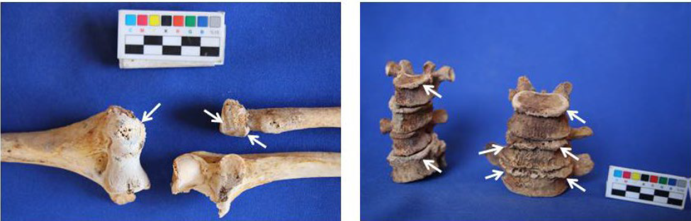
Fig. 8. pathological changes observed in the edge of the spine vertebrae (right) and left elbow.
Grave number 3
The remains obtained from this skeleton belong to a 25-35-year-old woman, which is similar to burial two located in this trench; behind this skeleton, there are three pieces of bricks in the shoulder, abdomen, and hip area. Next to this woman and in front of her chest, very small, fragile, and incomplete skeletal remains of a "child under one-year-old" (0-6 months) were discovered. This woman's skeleton is significantly damaged due to taphonomic and environmental factors inside the grave. The remains of brownish-black and redwood were also seen under this skeleton. This person's height based on the femur is about 141.8 ± 3.72 cm. In the initial study, pathological changes or fractures and violence were not observed in the bones. In the study of this person's teeth, signs of precipitation(plaque) on the teeth, erosion, periodontitis disease, and mandibular bone atrophy were observed.
Studies of the skeletons remains in trench two
Grave number 2
This grave was much shallower than other graves. The skeletal remains of two children were discovered immediately under the Lahad stone. The contents of the grave: the scattered remains of a child between 0-1 years old (the remains were incomplete, including the incomplete remains of teeth, long bones, and part of the skull and pelvis) and just in the western part of this grave, the skeletal remains of a smaller child between 0-3 month was discovered. The remains of this child are also significantly damaged (pulverized) and incomplete and include two ribs, long bones (broken), and a part of the skull. Unfortunately, due to the damage and displacement of the bones, the burial direction of these children remained unknown. Considering that the remains of these two children were incomplete, it was not possible to extract more information.
Grave number 3
The skeletal remains of this grave probably belong to a young man between 20 and 25 years old (Table 1). Just above the head of this skeleton (about 25-30 cm above the grave floor), incomplete skeletal remains (part of a skull, long bone, and rib) of a child under one-year-old (probably 0-6 months) were discovered. Because the gravestone on the child was in the continuation of the Lahad stone of this person, these two burials were likely related and done simultaneously. The depth of burial in this grave was less than the burials of women, and the evidence of Craibra Orbitalia was observed in the right eye of this person, which was not severe. Due to the taphonomic factors of the soil and burial, the teeth were severely damaged and crushed. The study of teeth did not show any pathological signs. The height of this person was estimated to be 165 ± 3.27 cm.
Grave number 4
The bones and the teeth remain of this child are incomplete and include milk teeth, crowns of permanent teeth, and a small part of the skull. Based on the teeth growth, the age of this child was estimated to be 1.5 to 2 years. It is impossible to determine children's gender from bones and teeth until puberty. Due to the incompleteness of these remains, pathological study was not possible.
Studies of the skeletons remains in trench three
Grave number 1
The skeletal remains of this grave belong to a woman about 50+ years old. This person had lost all his maxillary and mandibular teeth long before her death (Table. 1). The skeletal remains of this person are severely damaged and incomplete due to taphonomic factors inside the grave. The signs and pathological changes of metabolic disease-nutritional disorders, and osteoporosis were observed. Evidence of osteophytes was also seen in the spine of this person. The height of this person was estimated to be 150 ± 3.7 cm.
Table. 1. the bio-archaeological study of human skeletal remains discovered at the Sari Gol site.
Trench | Grave/skeleton number | Burial type | scull | Age at death | Gender | Bone paleopathology | Tooth paleopathology
I | 2/2 | one corpse in a grave | +  Broken | 50 +  years | female | Moderate DJD in the elbow, thoracic and lumbar vertebrae (T8-12, L1-5), and sacrum S1 | AMTL, Attrition, Calculus
I | 3/3 | Two corpses (1 adult/ 1 child) | + | 25-35 years | female | - | Periodontal disease, Attrition, Calculus
II | 2A, 2B | Two corpses in a grave (child 0-3 months and child  0-1 year | - | 0-3 months and  0- one year | child | - | -
II | 3/3 | two corpses in a grave) one child, one adult) | +  Broken | 20-25  year | male | Cribra Orbitalia (R) | -
II | 4/4 | one corpse in a grave | - | 1/5-2 Years | Child | - | -
III | 1/1 | one corpse in a grave | + Broken | 50 +  years | Female | Osteoporosis | Heavy AMTL, Atrophy mandible

Burials of the Sari Gol Crypt
A total of 318 complete and broken adult bones, two adult skulls, and 12 pieces of whole and broken children's skeletal were collected from 6 units (units 1, 2, 12, 16, 27, and 29) of the Crypt (Table. 2). In general, the remains of 10 adults (men and women of different ages) and two children (2-3.5 and 1.5-2.5 years old) were estimated in this Crypt. This number was determined based on the counting of long bones, which shows the minimum number of people buried in this Crypt. It is not possible to estimate the exact number of women and men. The study shows that in this Crypt, two women and one man were around 50+ old at the time of death. A woman died at the age of 18-25, and another person, whose gender was impossible to determine, also died at the age of 25-18. However, it was impossible to determine the age of the rest of the adults due to the incompleteness of the skeletons. The pathological study showed that some of these adults suffered from diseases, including degenerative joint and spine diseases, congenital and metabolic diseases, and, in some cases, infectious diseases. For instance, the study of the bones of one of the individuals in this set of bones shows a lateral deformity in one of the tibias. It probably refers to rickets in the person's childhood and maybe osteomalacia.
In addition to this, the pathological evidence in the bones shows spinal osteoarthritis disease and advanced and severe spondylosis in some spinal vertebrae, which is probably related to 2 men from this collection. Severe osteophytosis in the thoracic and lumbar vertebrae and on the atlas joint where the axial horn is located, adhesion of two thoracic vertebrae, and severe deformation in the six lumbar vertebrae and their joints is probably due to the degenerative disease of the spine joints and advanced and severe spondylosis (Fig.9). Also, in two cases, signs of repaired fractures (before death) were detected in a fibula bone of the left leg and a radius of the left hand (Fig.10).
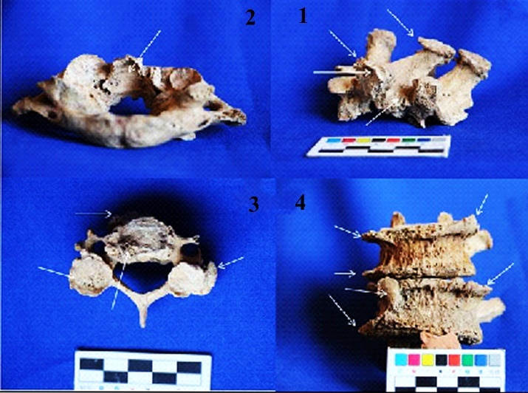
Fig.9. 1. two thoracic vertebrae adhesion, 2. Osteophytosis and deformity in the atlas joint where the axis horn is located, 3. the pathological changes of joint disease in the cervical vertebra, 4. and the lumbar vertebrae.
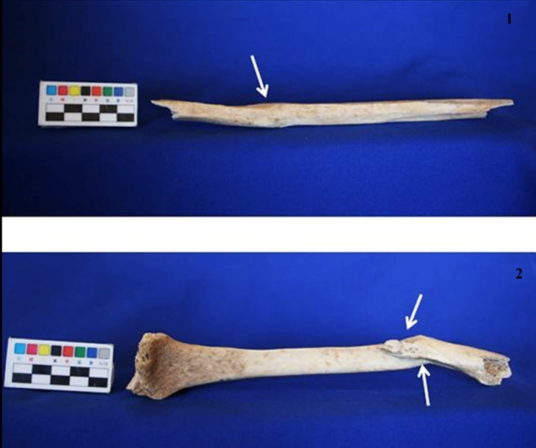
Fig.10. 1. fracture repaired during the person's lifetime (fibula), 2. and radius (bottom)
Table. 2. The number of people obtained from the Crypt based on stratification units
Unit | Minimum number of people | Pathology | Fractures
1 | one child and four adults | DJD of the joint surface on the right radial head; morphological changes, porosity, and deformation/distal fibula; and moderate DJD (thoracic vertebrae) | Heald trauma/ left fibula; healed oblique fracture/ left radius
2 | six adults and one child (It is possible to be related to unit 1) | Tibia with lateral deformity (childhood rickets!) | -
12 | two adults | Bone formation L4, L5 | -
16 | three adults | Porosity and deformity/lateral end/ R clavicle; DJD (on vertebral body/superior and inferior facets- one cervical vertebra). A skull with evidence of premature closure of the sagittal suture. | -
27 | six adults and one child | Fusion of two thoracic vertebrae; heavy porosity and osteophytes on thoracic vertebrae; porosity, eburnation, and osteophytes on the articular facet for dens/ one atlas (DJD); heavy bone formation and deformity and porosity on six lumbar vertebrae/on the body and articular facets joints (DJD- advanced spondylosis) | -
29 | three adults | Porosity and osteophytes/ head of one thoracic rib; DJD /T12 or L1 | -

Other findings
On the surface of this site, six pieces of pottery were found. All these potteries are bodies except for one part with a buff paste (according to Munsell 2.5 Y 6/8 Olive Yellow). The rest of their paste color is orangish red (Munsell 2.5 YR 6.8 Light red). All these potteries are wheel-made and fired enough. The outer and inner surfaces of these potteries have a lot of wear and sediment, and only one piece has buff paste, and its inner coating is a bluish-green glaze. It seems that some of them were covered with a wet hand or red wash. The allegation of these potteries is mineral, and brown sand can be seen in the paste of these pottery. In addition to the pottery, a piece of melted glass and a piece of marked brick were also found among the debris outside the Crypt (Fig.11).
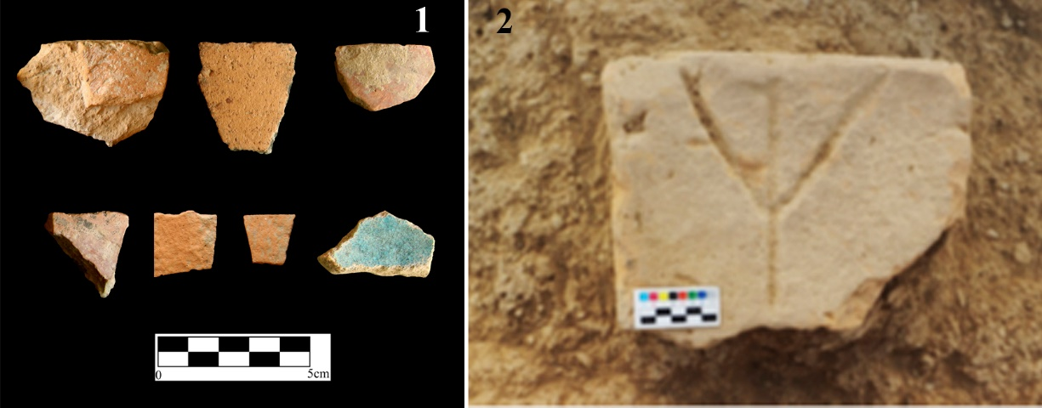
Fig.11. 1. Surface pottery of Sari Gol Crypt cemetery, 2. Marked bricks.
Discussion and conclusion
In the excavation of the Sari Gol site, a Crypt with a unique two-story architecture was found on the lower floor of the Crypt and a chamber on the upper floor, which shows that the Crypt room was built with a circular plan. Its entry is connected to a narrow corridor on the south side by a staircase. A rectangular chamber was found in this Crypt, built entirely underground, and many parts were lost. However, the remaining evidence shows that its entrance door was facing south and had a small porch. The inside of the building and its floor were plastered, but no evidence of its decorations was found. Two brick samples were selected from the Sari Gol tomb and delivered to Iran's Conservation and Restoration Research Institute to test thermoluminescence dating. The test results showed that these samples date back to about 370 ± 16 years ago, that is, about 1651 AD. The remaining evidence shows that unauthorized explorers have dug all the graves in the Crypt, and it does not provide any information about the manner of burials. The study results of the skeletal remains discovered in the Sari Gol Crypt indicate the existence of 10 adults (male and female of different ages) and two children in this Crypt. According to the condition of the bones, it is likely that the people were not buried under the soil, and maybe they were placed on the floor of the Crypt, and the destruction of the corpse was done outside the ground and inside the roofed Crypt. During the excavation of three trenches in this cemetery, six graves were excavated, of which three graves included double burials (adult-child and child-child). Most of the bones in these graves are also damaged due to the environmental conditions of burial, and some of them, like the skeletons of children, have been largely destroyed. Pathological evidence of degenerative joint diseases was discovered in many bones (spine, ribs, hand), and cases of repaired fractures were also seen. These signs show that some of the buried people have experienced severe physical and work pressures during their lives. Joint diseases of the neck vertebrae are likely to refer to carrying a load on the head. The initial studies of existing burials show that the children's death indicates the possibility of acute illness (such as infectious diseases) among these children, the low hygiene level, and the decrease in the health of children of that time in this site. The teeth were severely damaged and crushed due to taphonomic factors in all four adults found. In general, due to the pathological conditions of the teeth and mouth, these people have used less carbohydrates than protein in their diet.
Acknowledgment
This article is derived from the "Evaluation and analysis of human skeletons from the rescue excavation of Sari Gol Cemetery" research project, implemented in the Department of History, Shahid Chamran University of Ahvaz, Ahvaz, Iran, with project number 1129. The costs of implementing this project have been financed from the research credits of the research unit of Shahid Chamran University of Ahvaz. The authors express their gratitude. We thank Dr. Zahra Afshar for her help in studying of human skeletons.
References
AL-SHORMAN / KHWAILEH 2011
Al-Shorman, A./ Khwaileh, A., Burial practices in Jordan from the Natufians to the Persians. Estonian Journal of Archaeology 2, 88-108. DOI:10.3176/ARCH.2011.2.02.
ALEKSHIN et alii 1983
Alekshin, V. A./ Bartel, B./ Dolitsky, A. B./ Gilman, A./ Kohl, P./ Liversage, D./ Masset, C., Burial Customs as an Archaeological Source [and Comments]. Current Anthropology 2, 137-149. DOI:10.1086/202960.
BASS 2005
Bass, W. M., Human osteology: a laboratory and field manual. (Columbia: Missouri Archaeological Society).
BROTHWELL 1981
Brothwell, D. R., Digging up bones: the excavation, treatment, and study of human skeletal remains. (Ithaca, N.Y: Cornell University Press).

BUIKSTRA/ BBELAKER 1994
Buikstra, J. E./ Ubelaker, D. H., (eds.). Standards for data collection from human skeletal remains: proceedings of a seminar at the Field Museum of Natural History. Fayetteville. (Ark: Arkansas Archeological Survey. Research Seminar Series 44).
COLLIER 2005
Collier, A., Tradition, Modernity, and Postmodernity in Symbolism of Death. The Sociological Quarterly 4, 727-749. https://doi.org/10.1111/j.1533-8525.2003.tb00533.x.
FAHLANDER 2016
Fahlander, F., The materiality of the ancient dead: Post-burial Practices and Ontologies of Death in Southern Sweden AD 800–1200. Current Swedish Archaeology (CSA) 24, 137-162. http://dx.doi.org/10.17613/M6CQ2J.
FARSHI JALALI 2017
Farshi Jalali, F., the first season of rescue excavation of Sukh Cheshme area (Chandir dam basin). In: Ruholah Shirazi(ed). Reports of the 16th Annual Meeting of Iranian Archeology. (Tehran: Research Institute of Cultural Heritage and Tourism). 377-379(in Persian).
FARAJI RAD /KAZEMIAN 2016
Farajirad, K./ Kazemian, G., Spatial Analysis of Social and Cultural Factors as Driving Forces and Obstacles in Regional Spatial Planning and Development in Khorasane-Shomali Province. Journal of Applied Sociology 28/ 4, 155-172. doi: 10.22108/jas.2017.21737.
GESELL/ PRESTON/ COULSON 1990
Gesell, G./ Preston Day, L./ Coulson, W., Tombs and Burial Practices in Early Iron Age Crete, expedition 3, 22-30.
HOERNES/HEITZ/ LAIMER 2018
Hoernes, M./ Heitz, C./ Laimer, M., Revisiting the Dead: Tomb Reuse and Post-Burial Practices at Ascoli Satriano (Pre-Roman Apulia, Seventh–Fourth Century BC). Cambridge Archaeological Journal 2, 261–285.DOI: 10.1017/S0959774318000537.
HARKE 2014
Härke, H., Grave goods in early medieval burials: messages and meanings. Mortality: Promoting the interdisciplinary study of death and dying 19, 41-60. https://doi.org/10.1080/13576275.2013.870544.
JAFARI 2018
Jafari, M. J., Report of the first season of archaeological excavation of Tape Dolan, North Khorasan. IN: Ruholah Shirazi and Shoghaeg Horshid (eds). Reports of the 17th Annual Meeting of Iranian Archeology (Collection of Short Papers 2017), Volume 1. (Tehran: Research Institute of Cultural Heritage and Tourism). 237-231.
JAFARI/ RAJABI 2016
Jafari, M. J., Rajabi, N., Final Report of Chandir Dam. (Tehran: Archeology Research Center Archives) (unpublished). (in Persian).
KOUZEHGAR KALEJI/ RAHMATI/ ESMAEILZADEH/ 2022
Kouzegar Kaleji, L./ Rahmati, N./ Esmaeilzadeh, A., Spatial Analysis of Vulnerability of Urban Land uses Against Floods (Case study: Raaz City, Northern Khorasan province). Sustainable Development of Geographical Environment 4/ 6, 144-157. doi: 10.52547/sdge.4.6.144 (in Persian).
LORENZO 2015
Lorentz, K., Funerary Practices, Funerary Contexts, and Death in Archaeology. In: Robert A. Scott, Marlis Buchmann and Stephen Kosslyn (eds), Emerging Trends in the Social and Behavioral Sciences. (John Wiley & Sons, Inc).1-13. DOI: 10.1002/9781118900772.etrds0137.
MAQAMI MOGHIM et alii 2018
Maqami Moghim, G./ Hosseini, S. M./ Asadi, R./ Khani Tamleieh, S. Agroclimatic Zoning Cultivation Saffron in Khorasan Shomali Province: Approach to changing the pattern of cultivation. Geography and Development 17/ 56, 119-138. doi: 10.22111/gdij.2019.4899(in Persian).
NAJAFI et alii 2019
Najafi, M./ Mirghaderi, M. A./ Khanipour, M./ Jamshidi Yeganeh, S./ Rezaei Baghbidi, B., Human remains from Sar-Ney 3, Iran, 2019. Bioarchaeology of the Near East 13:54–59.
ORTNER 2003
Ortner D. J., Identification of pathological conditions in human skeletal remains. (San Diego, CA: Academic Press).
PRIYA 2017
Priya, E., Methods of skeletal age estimation used by forensic anthropologists in adults: a review. Forensic Res Criminol Int J 2, 41-51. DOI: 10.15406/frcij.2017.04.00104.
RAJABI 2012
Rajabi, N., Research and Identification of Archeology of Bojnourd County. (Bojnord: Archives of the Cultural Heritage, Handicrafts and Tourism of North Khorasan Province) (unpublished) (in Persian).
RAJABI 2018
Rajabi, N., Report of the second season of rescue excavation in Esmi site (Chatli Ola), Chandir Dam, North Khorasan. In: Ruholah Shirazi and Shaghaeg Horshid(eds). Reports of the 17th Annual Meeting of Iranian Archeology (Collection of Short Papers 2017), Volume 1. (Tehran: Research Institute of Cultural Heritage and Tourism). 451-455 (in Persian).
RAJABI 2019
Rajabi, N., Report of the third chapter of the rescue excavation of the nominal site 1 (Chatli Olad), Chandir dam, North Khorasan province. In: Ruholah Shirazi(ed). Reports of the 18th Annual Meeting of Iranian Archeology (Collection of Short Papers 2018), Volume 1. (Tehran: Research Institute of Cultural Heritage and Tourism). 331-334. (in Persian).
RETIEF / CILLIERS 2005
Retief, F. P./ Cilliers, L., Burial customs and the pollution of death in ancient Rome: procedures and paradoxes: the Roman world. Acta Theologica Supplementum 2, 128-146. DOI: 10.4314/actat.v26i2.52569.
REZAEE/ MOHEBBEE 2020
Rezaee, M./ Mohebbee, A., The Analysis of Spatio-Temporal Trends of Employment Index in the Border Villages of Raz and Jirgalan. Border Science and Techniques 9/ 3, 201-229. doi: Dor:20.1001.1.25384090.1399.9.3.7.9.
ROUSTAEI FARSI 2017
Roustaei Farsi, E., Report on the salvage excavation of Sari Gol cemetery and Crypt. (Tehran: Archeology Research Center Archives (unpublished)). (in Persian).

ROUSTAEI FARSI/ HEYDARI DASTENAEI/ AFSHAR 2017
Roustaei Farsi, E./ Heydari Dastanai, M./ Afshar, Z., The report of the rescue excavation of the site and Sari Gol in the Chandir Dam, North Khorasan. In: Ruholah Shirazi and Shoghaeg Horshid(eds). Reports of the 17th Annual Meeting of Iranian Archeology (Collection of Short Papers 2017). Volume 1. (Tehran: Research Institute of Cultural Heritage and Tourism), 539-544(in Persian).
SAMPER-CARRO et alii 2022
Samper-Carro, S./ Connor Sue O’, M./ Kealy, S./ Shipton, C., Talking Dead. New burials from Tron Bon Lei (Alor Island, Indonesia) inform on the evolution of mortuary practices from the terminal Pleistocene to the Holocene in Southeast Asia. PLoS ONE, 8: e0267635. https://doi.org/10.1371/journal.pone.0267635.
SILVA OLIVEIRA / MONTEIRO SILVA 2021
Silva Oliveira, M. A./ Monteiro Silva, S. F. S., Funerary Practices in Archaeology: Pluralities & Heritage. International Journal of Archaeology 2, 62-73. doi: 10.11648/j.ija.20210902.15.
SCHEUER/ BLACK 2000
Scheuer, L./ Black, S. M., Developmental juvenile osteology. (San Diego: CA, Academic Press).
TORRES- MARTINEZ et alii 2021
Torres-Martínez, J. F./ Fernández-Götz, M./ Domínguez-Solera, S./ Martínez-Velasco, A./ Vacas-Madrid, D./ Serna-Gancedo, M./ De la Torre, G. C./ Galeano, M./ Fernandes, R., Invisible Burials and Fragmentation Practices in Iron Age Europe: Excavations at the Monte Bernorio Necropolis (Northern Spain). Journal of Field Archaeology 46, 399-413.
UBELAKER 2004
Ubelaker, D. H., Human skeletal remains: excavation, analysis, interpretation. (Washington: Taraxacum).
WHITE/ FOLKENS 2005
White, T./ Folkens, P. A., the Human Bone Manual. (Amsterdam: Elsevier Academic).
Zanganeh Asadi, M. A./ Taqvi Moghadam, E./ Biramali, F., Detecting and evaluating periodic changes of Sombar border river in northeast Iran from river morphometric indicators and remote sensing. Border Studies Research 1, 107-132.

GESELL/ PRESTON/ COULSON 1990, 22; LORENTZ 2015; WHITE / FOLKENS 2005, 1; SILVA OLIVEIRA / MONTEIRO SILVA 2021, 62.
TORRES- MARTINEZ et alii 2021, 399.
RETIEF / CILLIERS 2005, 129.
ALEKSHIN et alii 1983, 137.
HARKE 2014, 41.
SAMPER-CARRO et alii 2022.
PRIYA 2017, 41.
See AL-SHORMAN / KHWAILEH 2011, 8.
For more information, see COLLIER 2005, 727.
See HOERNES / HEITZ/ LAIMER/ 2018, 261; FAHLANDER 2016, 139.
GESELL/ PRESTON/ COULSON 1990, 22.
WHITE / FOLKENS 2005, 2.
ROUSTAEI FARSI 2017, 8.
See ROUSTAEI FARSI/ HEYDARI DASTENAEI/ AFSHAR 2018.
REZAEE/ MOHEBBEE 2020, 210.
FARAJI RAD /KAZEMIAN 2016, 161.
KOUZEHGAR KALEJI / RAHMATI/ ESMAEILZADEH/ 2022, 149.
See ZANGANEH ASADI et alii 2018, 114.
MAQAMI MOGHIM et alii 2018, 123.
RAJABI 2011.
JAFARI/ RAJABI 2015.
FARSHI JALALI 2017.
JAFARI 2018.
RAJABI 2019.
ROUSTAEI FARSI/ HEYDARI DASTENAEI/ AFSHAR 2018.
RAJABI 2019.
ROUSTAEI FARSI 2017.
Lahad in the Islamic funeral rite is the narrow gap at the bottom of the grave to place the body, and the Lahad stones are placed above this gap completely covering the Lahad gap (See Najafi et alii 2019, 56).
Carbon and Nitrogen.
Oxygen (δ18O) ،Strontium (87Sr/86Sr).
BUIKSTRA / UBELAKER 1994; BROTHWELL 1981; BASS 2005.
SCHEUER/ BLACK 2000; UBELAKER 2004.
ORTNER 2003.

